|  |  |
| --- | --- |
|  |  |

|  |
| --- |
| **Grondwaterinstrumentarium iMOD Brabantse Delta** |

|  |
| --- |
| Auteur(s)  Joachim Hunink Tess op den Kelder Frans Roelofsen |

|  |
| --- |
|  |

|  |
| --- |
| **Grondwaterinstrumentarium iMOD Brabantse Delta** |

|  |  |
| --- | --- |
| Opdrachtgever | Waterschap Brabantse Delta |
| Contactpersoon | de heer K. Vink |
| Referenties | Referenties |
| Trefwoorden | Grondwaterinstrumentarium, iMOD, MODFLOW 6, MetaSWAP, WOFOST, grondwater, onverzadigde zone, validatie, Brabant Model, Brabantse Delta |

|  |  |
| --- | --- |
| Documentgegevens | |
| Versie | 0.1 |
| Datum | 08-07-2021 |
| Projectnummer | 11206534-000 |
| Document ID | - |
| Pagina’s | 57 |
| Classificatie |  |
| Status | concept  Dit document is een concept en uitsluitend bedoeld voor discussiedoeleinden. Aan de inhoud van dit rapport kunnen noch door de opdrachtgever, noch door derden rechten worden ontleend. |

|  |  |  |
| --- | --- | --- |
| Auteur(s) | | |
|  |  |  |
|  |  |  |

|  |  |  |  |  |
| --- | --- | --- | --- | --- |
| Doc. Versie | Auteur | Controle | Akkoord | Publicatie |
| 0.1 | Joachim Hunink |  |  |  |
|  |  |  |  |  |

Summary

In recent years, a consortium of various parties has been working on a groundwater model for the area of the Province of North Brabant. This groundwater model was developed in Triwaco using computational code of MODFLOW for the saturated zone and FLUZO for the unsaturated zone for the area-wide calculations (Verhagen, Steijn et al. 2019).

In this project, the existing model tool was converted to an iMOD model where the FLUZO model was replaced for the unsaturated zone model MetaSWAP. In addition, it was also made possible to calculate coupled with the crop growth model WOFOST.

Two variants of the model were calculated, one without and one with the online coupling with the crop growth model WOFOST. Next, a validation was performed in which the calculated groundwater levels and discharges were compared with measurements. This showed that there can still be large differences between the measured and calculated groundwater levels, caused partly by the model instrument and partly by the quality of the measurements. It is therefore recommended that before a regional calibration is performed the model instrument and the measurement set be improved.

The modeling process and postprocessing is set up in a workflow manager so that the set-up of the model is transparent, reproducible and extensible. The model input as the workflow with underlying scripts are part of the delivery.

Inhoud

Samenvatting 4

1 Inleiding 7

1.1 Achtergrond 7

1.2 Werkzaamheden 7

2 Achtergronden 8

2.1 iMOD en MODFLOW6 8

2.2 Gewasgroei model 8

2.2.1 Gewasgroeimodel WOFOST 9

2.2.2 WOFOST en MetaSWAP 10

3 Modelinstrument 12

3.1 Uitgangsmodel 12

3.2 Modelaanpassingen grondwatermodel 12

3.2.1 Lagenmodel 12

3.2.2 Waterlopen en drainage 12

3.2.2.1 Infiltratie en drainage weerstanden 12

3.2.2.2 Nat oppervlak 13

3.3 Onverzadigde zone 13

3.3.1 Landgebruik 13

3.3.2 Wortelzone 14

3.3.3 Bodem en database 14

3.3.4 Beregening 14

3.3.5 Meteorologische gegevens, potentiele verdamping en neerslag 15

3.3.6 Overzicht invoer MetaSWAP 15

3.4 Gewasgroeimodel (WOFOST) 16

3.4.1 Aangepaste invoer 16

3.4.2 Extra invoer 16

3.4.2.1 Crop file 16

3.4.2.2 Meteorologische gegevens, Penman Montheith 17

3.4.2.3 Overig 17

3.5 Stationaire grondwateraanvulling 18

3.6 Validatie dataset 19

3.6.1 Meetset grondwaterstanden 19

3.6.2 Meetset afvoeren 19

4 Resultaten 21

4.1 Modelresultaten 21

4.1.1 Grondwaterstanden 21

4.1.2 Verdamping 22

4.1.3 Grondwateraanvulling 25

4.1.4 Beregening 26

4.2 Validatie 27

4.2.1 Grondwaterstanden 27

4.2.2 Afvoeren 32

5 Aanbevelingen 35

6 Referenties 37

Bijlages 38

A Aanvullende figuren validatie grondwaterstanden 39

B Figuren validatie afvoeren 43

C Overzicht modelinvoerbestanden 48

D Beschrijving workflows modelopzet 49

E Beschrijving starten modelberekening 50

F Memo “Beknopte beschrijving recente afvoermodelleringen De Zeeuw Hellinga” 51

# Introduction

## Background

In recent years, a consortium of various parties has been working on a groundwater model for the area of the Province of North Brabant. This groundwater model was developed in Triwaco using MODFLOW calculation code for the saturated zone and FLUZO for the unsaturated zone for the area-wide calculations (Verhagen, Steijn et al. 2019).

The Brabantse Delta Water Board would like to apply the groundwater instrumentation itself in projects. In addition, there is a desire to link up with the national developments of the National Hydrological Instrument (NHI). For this reason, the water board has asked Deltares and WenR to convert the existing groundwater instrumentarium to an iMOD (Vermeulen, Roelofsen et al. 2020) environment in which the unsaturated zone is calculated using the MetaSWAP model, including the link between MetaSWAP and the crop growth model WOFOST (de Wit, Boogaard et al. 2019).

## Activities

The following work was performed for this project

1. Conversion of the existing Brabant Model (saturated zone) to MODFLOW6 in iMOD.

2. Updating of some model input files

3. Addition of unsaturated zone model MetaSWAP

4. Adding crop growth model WOFOST

5. Validation on groundwater levels and discharges.

The model was delivered for the area of interest of the Brabantse Delta Water Board. The output model contains the entire Brabant Model, which is the management area of the Province of North Brabant. There is deliberately no cut in the source files so that the model can easily be extended outside the area of the Brabantse Delta Water Board.

The model building process and postprocessing is set up in a workflow manager so that the set-up of the model is transparent, reproducible and extensible. Python package snakemake (https://snakemake.readthedocs.io/) was used as workflow manager.

# Background

## iMOD en MODFLOW6

To set up the groundwater model, the groundwater software iMOD was used. iMOD consists of a Graphical Interface (GUI) for viewing and analyzing model output and calculation code. MODFLOW is used for the groundwater flow calculations. Within iMOD, a version of MODFLOW2005 (Harbaugh 2005) adapted by Deltares or the MODFLOW6 (Hughes, Langevin et al. 2017) computational code can be used. MODFLOW6 is the latest version of the MODFLOW line and includes several new developments.

Within iMOD, the new developments around MODFLOW 6 are anticipated. MODFLOW 6 makes it possible to calculate with both structured and unstructured grids (e.g. quadtrees, octrees, triangles, etc.). It can also use, for example, nested calculations of models and model concepts. In addition, there are improved functionalities for e.g. protruding layers (iDOMAIN function) and drying cells (Newton formulation).

In addition to the GUI, it is also possible to automate data operations or analyses. For this, the batch functionality of iMOD can be used or use can be made of the imod python package (imod_python: https://imod.xyz/) that makes the data operations of iMOD file formats and working with large (spatial) datasets easier.

A switch to MODFLOW 6 in combination with MetaSWAP was made possible for structured calculations by the end of 2020. For this purpose, a BMI coupling was developed in cooperation between USGS and Deltares and implemented in the source code of MODFLOW 6. This has also been applied to the LHM 4.1 model (Hunink, van Engelen et al. 2020). Computing with the new coupling method has - when using structured grids - limited impact on the model results. However, it should be taken into account that the memory usage and computation time increase (order factor 2) because the full 3D calculation almost doubles the number of layers.

## Crop growth model

In the LHM, since the release of LHM 4.0, calculations are made with the link to the crop growth model WOFOST. WOFOST is also used within the Waterwijzer Landbouw (WWL). The groundwater model is delivered with and without the online coupling to the crop growth model WOFOST. Therefore, a comprehensive, general explanation of this model and the combined application of MetaSWAP and WOFOST is given first.

Crop growth can be included statically or dynamically in the calculations with MetaSWAP. With static crop growth, the actual transpiration is calculated per time step in MetaSWAP based on available soil moisture and meteorological conditions. With limited availability of soil moisture, reduction of transpiration can be calculated, but after improvement of the moisture conditions, it is possible that the crop can again potentially transpire following the predetermined crop growth pattern. To create this input, however, previously performed long-term calculations with WOFOST were used, which were post-processed into an annual average development pattern per crop.

With dynamic crop growth, on the other hand, the development of the crop is not imposed in advance. The crop growth model WOFOST computes coupled with MetaSWAP and in WOFOST the development of the crop is calculated based on the actual conditions (see the next section). Adverse conditions affect crop growth in this method. If crop growth is restricted, then in subsequent time steps this will have consequences on the calculated transpiration in the unsaturated zone model. Due to this feedback mechanism, the calculated crop evaporation in a dry year can differ significantly from calculations with static crop growth.

### Crop growth model WOFOST

In the crop growth model WOFOST (WOrld FOod Studies; Boogaard et al., 2011), potential crop yield is calculated as a function of CO2 content, solar radiation, temperature, and crop characteristics. Then hydrological conditions determine the actual crop production, limited or not. The basis for calculating crop growth is leaf area and incoming solar radiation, see Figure 4.1.

The amount of light and CO2 captured by the leaves and potentially converted by photosynthesis is calculated in WOFOST. Actual photosynthesis is then calculated by reducing potential photosynthesis for limited moisture availability for evaporation and possibly also oxygen deficiency or excessive salt concentrations. Part of the energy is used for maintenance respiration and growth respiration. The remaining part is converted into dry matter, which is distributed to the different parts of the crop depending on the temperature and development stage of the crop: the roots, stems, leaves and storage organs (see Figure 2.2).

WOFOST can take into account the influence of extreme weather conditions, such as high rainfall intensities, prolonged drought, increases in CO2 and changing temperatures. As a result, crop development will be different each year due to variation in meteorology and hydrology.

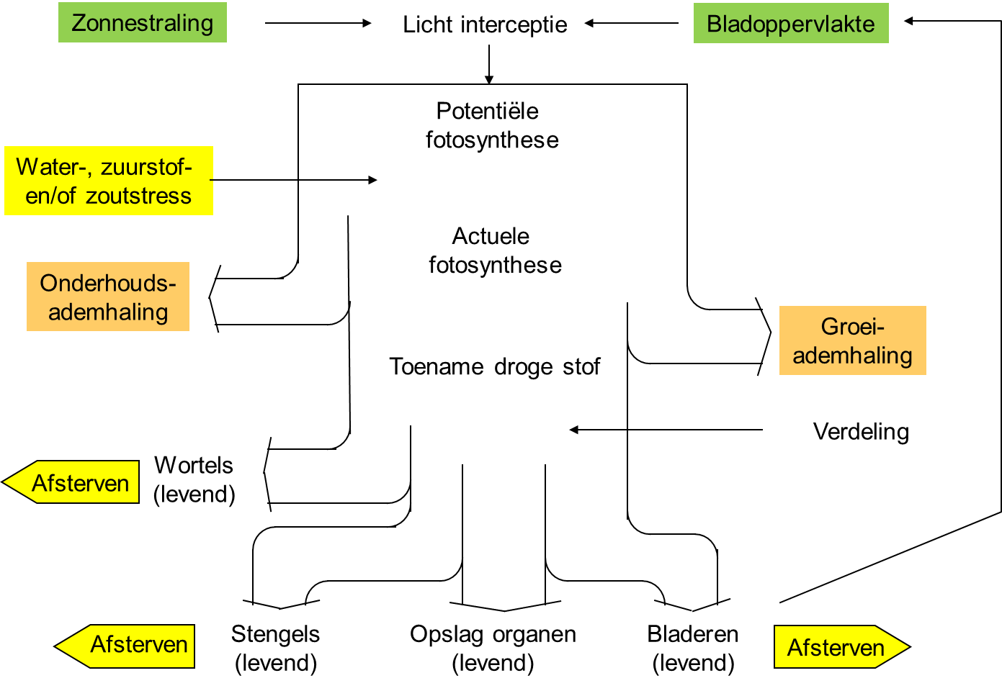

Figuur 2.1 Een schematische weergave van de gewasprocessen in WOFOST (Mulder et al., 2018).

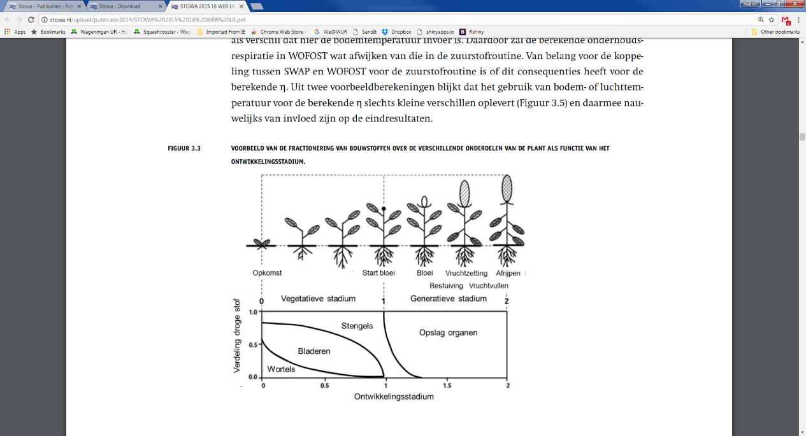

Figuur 2.2 Een voorbeeld van de verdeling van droge stof over de verschillende plantonderdelen (Mulder et al., 2018).

### WOFOST en MetaSWAP

Not all crops can be computed using WOFOST at this time because only parameterizations are currently available for a limited number of crops. The crops are consistent with the crops from the Agricultural Water Guide (WWL) version 2.0. They are the following crops:

- Grass

- Corn

- Potato

- Beet

- Other agricultural crops

- Fruit farms

For Fruit farms and Other agricultural crops, the WOFOST guide crop Potato is used. Fruit farms and Other therefore have the same parameterization as Potato.

More crops have become available in the new release of WWL 3.0 (WWL 2022). It is possible to further expand the crops if additional data are available. This is further explained in section 3.4.

Within WOFOST, crop growth is dynamically simulated where crop growth depends on meteorological and hydrological conditions. Thus, WOFOST provides a realistic dynamic boundary condition for the calculation of transpiration in the MetaSWAP calculations.

The potential crop growth in WOFOST depends on meteorological conditions. This includes the following processes:

- Potential evaporation;

- When the crop can germinate (depending on temperature, among other things);

In addition, the potential crop growth within MetaSWAP-WOFOST is limited if farmers cannot go on land with farm machinery until later due to wet conditions, these are the so-called indirect effects. Actual crop growth is additionally limited by hydrological conditions. Figure 2.3 shows the potential crop development of MetaSWAP-WOFOST for three example years.

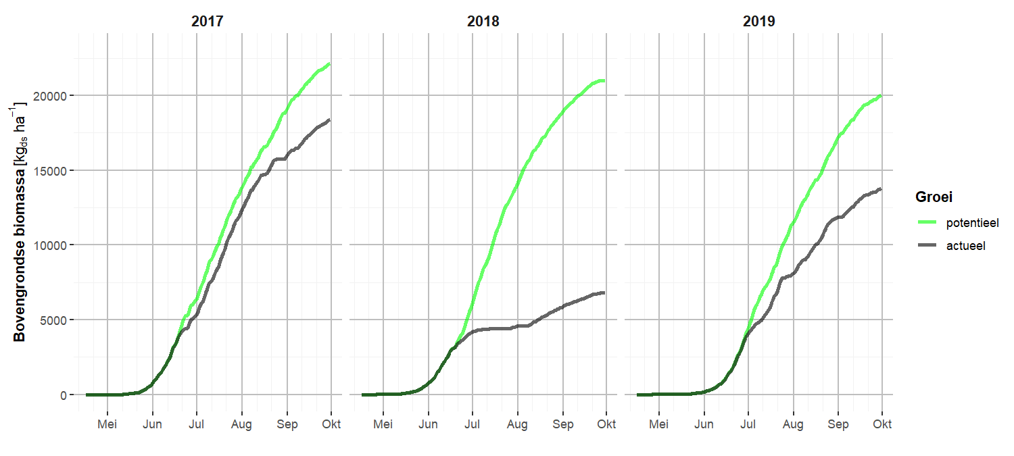

Figuur 2.3 Gewasontwikkeling van de bovengrondse biomassa voor verschillende jaren; met in het groen de potentiele gewasontwikkeling en in het zwart de actuele gewasontwikkeling

All other crops, such as tree crops and bulbs, are not calculated with WOFOST. These crops have static crop growth in MetaSWAP that is the same every year.

In MetaSWAP-WOFOST, there can be 4 causes of damage:

1. Indirect damage due to less favorable conditions in spring/autumn

2. Drought stress : αdrought.

3. Oxygen stress : αoxygen

4. Salt stress : αsalt

The dynamically calculated crops include indirect damage, drought stress and oxygen stress. In the oxygen stress calculation, evaporation reduction is included in the calculation but not the feedback to crop development. If the feedback is used, crop development in wet conditions is too strongly influenced, so this functionality is not yet used. Salt stress is currently not calculated because these processes still have to be validated in MetaSWAP. Therefore, this option is not yet available in the calculation code.

The so-called indirect damage to crop production occurs when, due to hydro-logical conditions, the growing season is shorter than what is optimal for a given crop in a given year. Shortening of the season can occur in both spring and fall. In spring, when the crop gets going, delays may occur in one or more of the following phases:

- Performing preliminary tillage due to conditions too wet for machinery;

- Seeding or planting due to conditions too wet for the machinery and/or too cold for the crop;

- Germinating the crop due to too low temperature and/or less favorable moisture conditions.

For statically calculated crops, only drought stress is included. However, it is possible to apply WWL agriculture based on groundwater levels calculated by the groundwater model. The WWL metarelations or the regional application can be used for this purpose.

Tabel 2.1 Overzicht beschikbare schade termen

|  |  |  |  |  |
| --- | --- | --- | --- | --- |
|  |  | Indirecte schade | Directe droogteschade | Directe natschade |
| Gewassen met dynamische gewasgroei | * Gras * Mais * Aardappel * Bieten * Overige landbouwgewassen (als aardappel) * Fruitkwekerijen (als aardappel) | WOFOST | WOFOST | WOFOST |
| Gewassen met statische gewasgroei | Andere gewassen | Niet beschikbaar | Beschikbaar o.b,v. Feddes. | Is mogelijk via Feddes parameters |

The coupling MetaSWAP-WOFOST has been developed in the program Lumbricus and is currently operational in the LHM and the regional groundwater model of Waterschap Aa en Maas. The user manual of the coupled instrument is not yet available so that for the backgrounds and model inputs of WOFOST can be found in the technical description of the model itself (Boogaard, A.J.W. de Wit et al. 2011) and the manual of MetaSWAP (Walsum 2020). It is expected that from NHI in 2022 work will be done to update documentation of model codes and model data, which is expected to include additional documentation of the MetaSWAP-WOFOST coupling.

# Modelinstrument

## Output model

The Brabant Model developed by RHDVH (Verhagen, Steijn et al. 2019) was used for the output model. This model was developed in the Triwaco model environment. Several models can be created from the Triwaco environment. For this project, a conversion of the data from the Triwaco environment to iMOD files with different resolutions was used. This conversion was performed by Brabant Water where this model version is already being used. The layer model here has a resolution of 100m, many other files (of surface water, for example) have a resolution of 25m.

## Model adaptations groundwater model

### Layer model

The output model contains 19 model layers. The MF2005 Brabant model calculates with a quasi 3D schematisation. This means that the model layers describe the aquifers where horizontal flow takes place; only vertical flow can take place through the aquitards. MODFLOW 6 computes fully 3D. For the transfer to MODFLOW 6, the layer model was therefore converted from a 19-layer model to a 37-layer model, with the permeabilities of the 37 model layers calculated from the top and bottom of the model layers (Figure 3.1). The horizontal permeability and vertical permeability (k-value) of the MODLFOW 6 model layer were calculated from the permeability of the aquifers and the resistance of the aquitards, respectively. An anisotropy of 1 was assumed so that the horizontal k-value is equal to the vertical k-value.

The k-value of the MODFLOW 2005 aquifers (wvp's) was determined by:

k=kD/d

Containing:

k = permeability (m);

kD = permeability (m2/d);

d = thickness of aquifer (m).

The k value of the MODFLOW 2005 aquitards (sdl's) was determined by:

k=d/c

Containing

k = permeability (m);

d = poorly permeable layer;

c = resistivity (days).

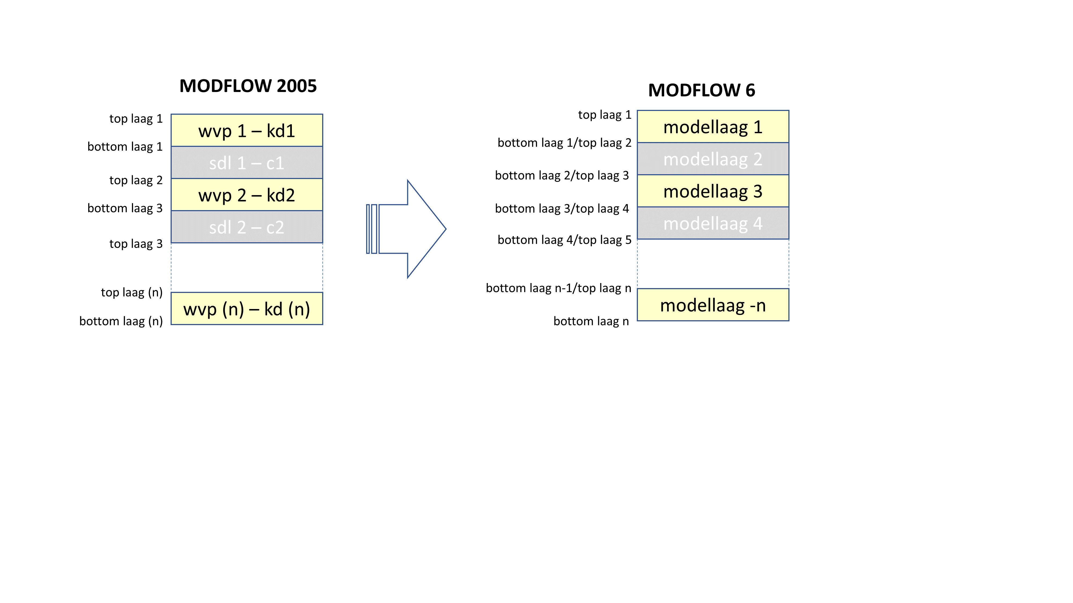

Figuur 3.1 Conversie MODFLOW 2005 lagenmodel naar MODFLOW 6 lagenmodel.

The fractures present in MF2005 Brabant model have been assigned to the new layer model. In the MF2005, the MOFLOW HFB package is used for the fractures where an additional resistance is assigned to a fracture line. The MODFLOW 6 model also used the HFB package where it was assumed that in the MODFLOW 6 model the same layers are influenced by the fracture as in the MODLFOW 2005, in such a way that each fracture system affects the same aquifer. The fractures are also assigned to the intervening aquitards. This means that if a fracture is active in model layer 2 in the MF2005 model, it is active for model layers 3 and 4 in the MODLFOW 6 layer model.

### Waterlopen en drainage

#### Infiltratie en drainage weerstanden

MODFLOW 6 does not account for the fact that infiltrating water from surface water often undergoes greater resistance than draining water to surface water. This is caused partly by different flow paths and largely by the deposition of silt in the infiltrating scenario, which clogs pores.

The iMOD version of MODFLOW 2005 incorporates the concept of infiltration factor. This makes it possible to use a different resistance for a watercourse for a draining or an infiltrating situation. This concept is not present in MODFLOW 6.

A similar behavior is mimicked in MODFLOW 6 by using a combination of the DRN and RIV packages. By assigning both packages in a cell, and therein equating the drain height of the DRN to the water level in the RIV package, the relationship between the infiltration factor and the conductances of these packages is shown:



Wherein the infiltration factor is, and and the conductances for the DRN and RIV package are, respectively. The conductance is calculated as follows:



Withas the flow-through area and the resistance in the surface-groundwater interaction in days.

The disadvantage of this option is that it doubles the number of watercourse systems in the model. This has disadvantages for the transparency of the model input and for the amount of model output.

The above method was applied in the MODFLOW 6 model. The breakdown to a draining and infiltrating subsystem per watercourse was already available in the output model. These data were adopted into the iMOD model for this reason.

#### Wet Surface

The unsaturated model MetaSWAP requires information on the wet surface area for each model cell. This information is used because MetaSWAP is not active within the surface water of a cell.

The wet surface was not fully available in the model database of the output model. For this reason, wet surface was calculated from a number of data files:

* Wet surface of the legger (based on data from the output model).
* Location of the Meuse in the model input. On the cells where the Meuse is present, a 100% wet surface was assigned.
* Location of the detail watercourses in the model input. In the output model, only the conductance of the watercourse was available. Based on the conductance input of the detail watercourses and a resistance of 5 days, the wet surface was determined for each model cell. This 5 days is consistent with the assumptions in the output model and was determined in consultation with Brabant Water.
* Location of polder levels in the model input. Part of the watercourses in the polder are not schematized as individual watercourses in the model input, but as an area-wide water system at a resolution of 250m. Since for this system in the output model only the conductance is available and known, it was not possible to determine the wet surface per model cell. Therefore, based on a resistance of 10 days, the wet surface per model cell was calculated at a resolution of 25x25 m. This 10 days is an estimate and will mean some areas a deviation from the actual wet surface.

## Unsaturated zone

The unsaturated zone model MetaSWAP used data provided by Wageningen Environmental Research (WenR) and parameterization of MetaSWAP as used in the LHM 4.1. All grid input from MetaSWAP is available at a resolution of 25m.

### Land use and crop

Land use is based on LGN7. A separate crop type can be defined for each land use. The link between land use code and crop type is described in the MetaSWAP input luse_svat.inp. Crop development can be calculated either statically or dynamically. With static crop development, an annual crop development per crop is specified in the MetaSWAP input (fact_svat.inp). Table 3.1 lists distinguished land use types and associated crop types. Some crops have the same potential crop development because the detailed is not yet available. These data can be updated later if a more comprehensive fact_svat.inp with more crops is available.

With dynamic crop development, there will be a different linkage table because a distinction can be made in WOFOST in the crop calculation between crops.

Tabel 3.1 Onderscheiden landgebruik en gewassen in de MetaSWAP schematisatie

|  |  |  |  |  |
| --- | --- | --- | --- | --- |
| Landgebruik code | Description | Beschrijving | Gewascode (fact_svat.inp) | Gewascode bij koppeling met WOFOST |
| 1 | Grass | gras | 1 | 1 |
| 2 | Maize | mais | 2 | 2 |
| 3 | Potatoes | aardappelen | 3 | 3 |
| 4 | Beets | bieten | 3 | 4 |
| 5 | Grains | granen | 3 | 5 |
| 6 | Other agricultural use | overige landbouwgew | 3 | 3 |
| 7 | Tree cultivation | boomteelt | 7 | 7 |
| 8 | Greenhouse cultivation | glastuinbouw | 8 | 8 |
| 9 | Orcard | boomgaard | 11 | 11 |
| 10 | Bulbs | bollen | 10 | 10 |
| 11 | Deciduous forest | loofbos | 11 | 11 |
| 12 | Coniferous forest | naaldbos | 12 | 12 |
| 13 | Marsh | moeras | 13 | 13 |
| 14 | Dune Vegetation | duinvegetatie | 14 | 14 |
| 15 | Bare ground | kale grond | 15 | 15 |
| 16 | Water | water | 16 | 16 |
| 17 | Natural grass | natuurlijk gras | 1 | 1 |
| 18 | Urban | stedelijk | 18 | 18 |

The urban area can be incorporated into iMOD in two ways. If land use class 18 is specified, the entire area is schematized as an urban area in MetaSWAP. Additionally, a paved surface must also be specified in iMOD. If a cell has a paved surface greater than 0, an svat with land use 18 and an svat with land use 1 are created for that cell, both of which are linked to the same MODFLOW cell.

### Root Zone

The root zone depth appears in two places in the MetaSWAP model input. For a static crop calculation (without WOFOST), the root zone for several crops is available as an annual time series. This input is described in the MetaSWAP input file fact_svat.inp. Additionally, a maximum root zone depth for each crop must be specified in the file area_svat.inp. If the crop development is calculated dynamically (with WOFOST), then the root depth of the crop is determined by the maximum in area_svat.inp and the WOFOST calculation.

### Bodem en database

The soil map and database use the SCR654 database with 370 units, which is applied in LHM 4.1. This is associated with the MetaSWAP database LHM2018_v02v, featuring a uniform root density distribution from LHM 4.1.

In the Waterwijzer Agriculture project, it was found that some clay soils calculate an evaporation reduction that is too high. Therefore, certain building blocks in the profiles have been modified. The replacement of the clay building blocks was implemented as follows:

* staro12 replaced by staro11
* staro13 replaced by staro12
* starb11 replaced by starb10
* starb12 replaced by starb11

### Beregening

The amount of irrigation from groundwater and surface water is calculated in MetaSWAP. For each model cell, it is specified whether irrigation can take place or not. Additionally, each location specifies a source from which irrigation water is extracted (groundwater or surface water), and if groundwater is used, from which MODFLOW model layer.

The map of potential irrigation locations is based on the national NHI file with a resolution of 25x25 m. Based on the water supply map of the water board, a distinction is made between irrigation from surface water or groundwater. All irrigation locations in managed water level areas are assigned to surface water, while those in freely draining areas are assigned to groundwater.

If irrigation is sourced from groundwater, the model layer from which extraction occurs is determined based on the layer model, selecting the first well-permeable model layer. The layer assignment is determined based on the following criteria:

* at least 2 meters deep
* extraction in model layer 3 or deeper
* minimum kD value of 100 m²/day

### Meteorologische gegevens, potentiele verdamping en neerslag

For meteorological data, information from Meteobase and KNMI has been used.

MetaSWAP utilizes daily grids of potential Makkink evaporation and daily precipitation totals in mm/day. Meteobase contains grids of potential Makkink evaporation and precipitation up to December 31, 2019. The data from Meteobase within the water board's area of interest was provided by the water board after it became evident that parties not affiliated with WIWB could not access this data via script. The Meteobase data was then combined with grid data from KNMI to create comprehensive files for the entire model area of the Province of North Brabant. Additionally, grids were extended up to 2020 using KNMI data (https://dataplatform.knmi.nl/). For precipitation, the KNMI-RD1 dataset was used, and for potential Makkink evaporation, the KNMI-EV24 dataset was utilized.

### Overzicht invoer MetaSWAP

The input for MetaSWAP can be divided into two parts:

Grid-based input

“inp” input (text files)

After preprocessing performed by iMOD, the spatial files are converted to text files for the schematization in MetaSWAP. The table below provides an overview of the model input for the MetaSWAP model.

Tabel 3.2 Overzicht MetaSWAP invoer

|  |  |  |  |
| --- | --- | --- | --- |
| Description | Eenheid | Bestandsnaam | Opmerkingen |
| Grid-based input |  |  |  |
| Model boundaries MetaSWAP | - | ibound_l1.idf |  |
| Land use | - | lgn.idf |  |
| Root depth | cm | rootzone_cm.idf |  |
| Soil map | - | Bodem370.idf |  |
| Meteorological station number | - | meteostation.idf | Used only for calculations with WOFOST. |
| Surface elevation | m NAP | mv_25m_model.idf |  |
| Irrigation map | - | irrigation_source.idf |  |
| Irrigation layer | laagnummer | irrigation_laag.idf |  |
| Maximum irrigation capacity | mm/d | 25 |  |
| Wet surface | m2 | nat_oppervlak.idf |  |
| Surface urban area | m2 | verhard.idf |  |
| Ponding depth urban | m | 0.002 | Standard value |
| Ponding depth rural | m | 0.002 | Standard value |
| Runoff resistance urban area | dagen | 1 | Standard value |
| Runoff resistance rural area | dagen | 1 | Standard value |
| Runon resistance urban area | dagen | 1 | Standard value |
| Runon resistance rural area | dagen | 1 | Standard value |
| Infiltration capacity urban area | mm/d | 0 | Standard value |
| Infiltration capacity rural area | mm/d | 1.05 | Standard value |
| Top of perched water tables | m NAP | 9999 | Standard value |
| Calibration factor soil moisture coefficient | - | 1 | Standard value |
| Calibration factor ksat | - | 1 | Standard value |
| Other MetaSWAP input |  |  |  |
| Crop factors |  | fact_svat.inp |  |
| Land use properties |  | luse_svat.inp | Separate version without and with WOFOST linkage. |
| Meteorological files |  | mete_grid.inp | New file needed for linkage with WOFOST. |
| General settings and reference to MetaSWAP database |  | para_sim.inp | Separate version without and with WOFOST linkage. |
| Output control for MetaSWAP (daily output or other time step length) |  | tiop_sim.inp |  |
| MetaSWAP initialization file (state-file) |  | init_svat.inp |  |
| Output control model output (per time step in tiop_sim.inp) |  | sel_key_svat_per.inp |  |

The most up-to-date documentation of MetaSWAP can be requested via the NHI helpdesk (helpdesk.nhi@deltares.nl). The content and format of the MetaSWAP input files are described in (Walsum 2020).

## Gewasgroeimodel (WOFOST)

To calculate with WOFOST, files need to be modified and additional files must be available in the calculation directory of MetaSWAP. This is described in this section.

### Modified input

To calculate with WOFOST, three MetaSWAP files need to be modified:

* Para_sim.inp  
  Modifications in settings for crop growth and evaporation concept, and additional settings for WOFOST.
* Luse_svat.inp  
  Modifications in crop code for land use types 1 through 5, adjusted eic_opt (option parameter for interception simulation), required for calculations with WOFOST.
* Mete_grid.inp  
  Extension to reference additional meteorological files for Penman-Monteith calculations.

### Extra invoer

#### Crop file

WOFOST uses crop files (*.crp) that describe the crop parameters. In the file vg2crp_svat.inp, the crops are linked to the MetaSWAP crop ID.

#### Meteorologische gegevens, Penman Montheith

Within WOFOST, the potential evaporation for crops calculated using WOFOST is determined based on the Penman-Monteith method, requiring additional input. The extra parameters for the Penman-Monteith equation within WOFOST are:

* **TN**: minimum daily temperature
* **TX**: maximum daily temperature
* **TG**: mean temperature
* **Q**: radiation
* **UG**: humidity
* **FG**: wind speed

The meteorological input for WOFOST is based on the interpolation of KNMI station data (<https://www.knmi.nl/nederland-nu/klimatologie/daggegevens>). The nearest neighbor interpolation method is used, which fills the grid with the nearest value. This can lead to sharp transitions in the meteorological input that may be reflected in the calculated evaporation.

For the Penman-Monteith calculation, the station number is also used. When using Penman-Monteith grids (in the linkage with WOFOST), the meteorological station number is used only for the elevation of the station relative to sea level (for recalculating air pressure) and the height of the wind measurement above ground level (standard 10 m).

#### Overig

In addition to the crop files, several extra files are required for calculations with WOFOST:

* **comp_post.csv**  
  Describes the thickness of the compartments for PostMetaSWAP.
* **dqsat_svat.inp**  
  Describes the depth for linking groundwater fluxes to the PostMetaSWAP profile, including information on fluxes within the compartment and moisture levels. Standard value, the number of defined svats must at least match the number of svats in the model being calculated.
* **para_post.inp**  
  Control file for PostMetaSWAP.
* **hcrit_svat.inp**  
  Specifies pressure head criteria for the indirect damage effects of the crop growth simulation.
* **sel_key_wof_per.inp**  
  Defines the output variable of WOFOST (for a description of the WOFOST output variables, see the MetaSWAP manual in the section describing this file).

Tabel 3.3 Overzicht aanvullende WOFOST invoer

|  |  |  |
| --- | --- | --- |
| Beschrijving | File | Omschrijving |
| Aangepaste MetaSWAP invoer |  |  |
| Landgebruik eigenschappen | luse_svat.inp | Aparte versie zonder en met WOFOST koppeling. |
| Meteobestanden | mete_grid.inp | Nieuw bestand bij koppeling met WOFOST nodig. |
| Algemene instellingen en verwijzing naar MetaSWAP database | para_sim.inp | Aparte versie zonder en met WOFOST koppeling. |
| WOFOST crop files |  |  |
|  | *suikerbiet.crp* |  |
|  | *zomergerst.crp* |  |
|  | *snijmais.crp* |  |
|  | *gras_maaien.crp* |  |
|  | *aardappel_ov.crp* |  |
|  | *vg2crp_svat.inp* |  |
| Aanvullende MetaSWAP-WOFOST bestanden |  |  |
| Informatie meteorologische stations | Mete_stat.inp | Informatie van de meteorologische stations. |
| Invoer PostmetaSWAP | comp_post.csv | Beschrijving van de dikte van de compartimenten voor PostMetaSWAP. |
| Profielen PostMetaSWAP | dqsat_svat.inp | Beschrijving van de diepte voor de koppeling met de grondwaterfluxen naar het PostMetaSWAP profiel, inclusief informatie van fluxen in het compartiment en vochtgehaltes. Standaard waarde, aantal gedefenieerde svat’s dient minimaal het aantal svat’s van het door te rekenen model te bevatten. |
| Control file voor PostMetaSWAP | para_post.inp |  |
| Stuurfile indirecte schade effecten. | hcrit_svat.inp | Specificeert drukhoogtecriteria voor de indirecte schade-effecten van de gewasgroeisimulatie. |
| Stuurfile output WOFOST | sel_key_wof_per.inp | Definitie van de outputvariabele van WOFOST (voor beschrijving van de outputvariabelen van WOFOST zie MetaSWAP handleiding bij de beschrijving van deze file). |

The crops that can currently be calculated with WOFOST come from Waterwijzer Agriculture version 2.0. If crop files for WOFOST become available, it will be possible to expand the crops calculated with WOFOST. For this, the crop files (*.crop files) must be expanded, and it must be indicated in the MetaSWAP input that the crop is dynamically calculated with WOFOST.

|  |
| --- |
|  |

## Stationaire grondwateraanvulling

This chapter describes how groundwater recharge in the RCH package of iMOD is determined. The RCH package is used in the stationary model. In a non-stationary model, groundwater recharge is standardly determined with MetaSWAP.

To calculate the long-term groundwater recharge from MetaSWAP results for the RCH package, the following formula is used: RCH=Ebs+qinf+Tact

where:

* **RCH** = groundwater recharge
* **Ebs** = ‘bare soil’ evaporation
* **qinf** = soil infiltration flux
* **Tact** = actual transpiration

This calculation is based on a water balance of the root zone. The **qinf** represents the soil infiltration flux to the root zone, while **Tact** and **Ebs** are loss terms due to evaporation from the upper layer of the unsaturated zone. The remaining water is then available for groundwater recharge.

This calculation does not account for storage changes in the saturated and unsaturated zones and therefore can only be used with long-term average calculations. This formula can be applied to all svats where MetaSWAP is active, covering both rural and urban svats. Since MetaSWAP is not active for open water surfaces, no groundwater recharge is calculated for surface water. However, the model does calculate interactions between surface water schematized in MODFLOW and groundwater.

For calculating daily groundwater recharge, the daily storage coefficient and groundwater level must be considered. In iMOD 5, a function is available for this purpose (MSPNETRCH iMOD batch function, Vermeulen, Roelofsen et al. (2020)).

$$NetRCH= ∆lvgmodf*sc1-qmodf$$

Where

* **lgvmodf** = calculated head in model layer 1
* **sc1** = long-term average storage coefficient determined with MetaSWAP
* **qmodf** = sum of all MODFLOW fluxes

The groundwater recharge for the stationary model is calculated based on MetaSWAP calculations over a period considered representative; the period 2011-2018 was chosen during development. The average groundwater recharge is then applied as stationary recharge in the model.

The calculated groundwater recharge is shown in Figure 4.8. The model calculations were performed only for the water board's management area. In some areas, groundwater recharge can be negative. Negative groundwater recharge means there is capillary rise from the groundwater system to the unsaturated zone (MetaSWAP). Negative calculated groundwater recharge can occur in areas where groundwater levels are above the surface in combination with a high seepage flux. Groundwater levels above the surface can occur when the surface elevation of a cell is lower than the level in the RIV package of a neighboring cell. In areas with high conductance in the RIV package, significant water infiltration can occur, causing the groundwater level in the neighboring cell without a draining watercourse to be calculated too high.

Due to the combination of groundwater levels above the surface and a seepage flux, the soil infiltration flux in MetaSWAP (**qinf**) is also negative in these areas. The approach to groundwater recharge used for the stationary model is not representative here. Large negative groundwater recharge is undesirable and implausible for the stationary model. Therefore, the negative values of infiltration (**qinf**) were set to 0 during the groundwater recharge calculation.

## Validatie dataset

A validation was conducted on the calculated groundwater levels and the model's calculated discharges.

### Meetset grondwaterstanden

For validating the calculated groundwater levels, two existing measurement sets were used:

* The calibration set used during the calibration of the Brabant Model (Verhagen, Steijn et al. 2019)
* A measurement set with verified measurements from the water board.

The measurements were assigned to the new layer model based on filter settings, and the deviation between each measurement and the calculated groundwater level was determined. For shallow measurements, the deviation between the calculated and measured GHG (highest groundwater level), GLG (lowest groundwater level), and average groundwater level was determined. Shallow measurements were selected based on resistance within the layer model. All measurements with cumulative resistance of less than 100 days between ground level and model layer were labeled as phreatic. For deep measurements, only the deviation from the average groundwater level was considered.

### Discharge Measurement Set

The water board provided net discharge data for 5 water balance areas (see also Figure 3.1). The measured discharge time series are incomplete and contain gaps. Therefore, the water board performed discharge modeling based on the De Zeeuw-Hellinga equation. This modeling allowed nearly every discharge series in the freely draining area to be filled where data was missing and extended the time series for periods with no available measurements. Using this method, daily discharge data for the 5 discharge areas became available and could be compared with the calculated discharge from the groundwater model. A point of consideration with the modeled data is that high discharges can be well represented, but the short-term dynamics of low discharges from the original measurements are not captured. The modeling of the measured discharges is further detailed in Appendix F.

In the validation, the measured discharge (based on the time series model) was compared with the net discharge from the MODFLOW and MetaSWAP models. For the modeled net discharge, the following terms were summed:

* **MODFLOW**
  + RIV (infiltrating + draining watercourses)
  + DRN
* **MetaSWAP**
  + QrunQ_{run}Qrun​: surface runoff.

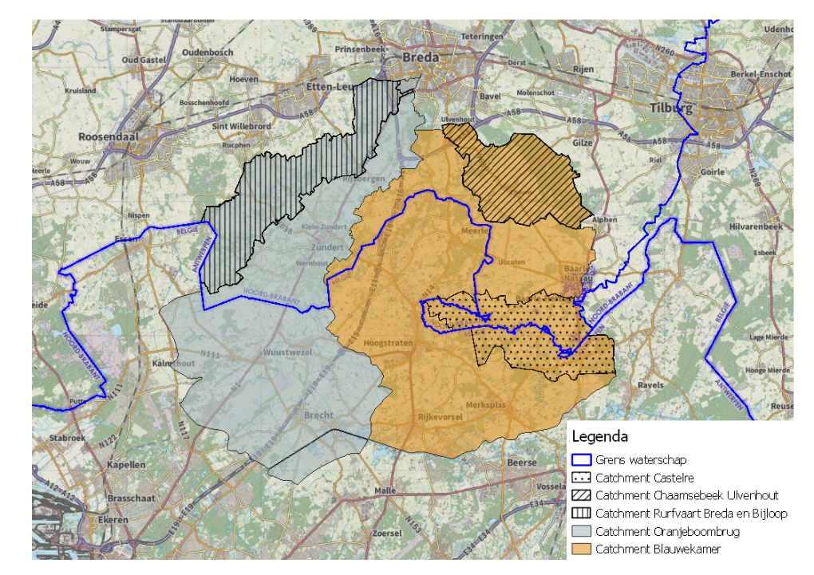

Figuur 3.2 Ligging van de waterbalans gebieden.

# Resultaten

The groundwater model was run for the period from 1-1-2000 to 31-12-2018 for the management area of the Brabantse Delta water board, including a 5 km buffer. The calculated area lies between x-coordinate 67000 and 369000 and y-coordinate 141000 and 421000. The model was calculated at a resolution of 100m.

Two model variants were run: a model without the linkage to WOFOST (**BrDe_metaSWAP**) and a model with the linkage to WOFOST (**BrDe_metaSWAP_WOFOST**). The differences between the model calculations with and without the WOFOST linkage were analyzed for the calculated groundwater levels and actual transpiration. Additionally, a validation was conducted on the calculated groundwater levels and discharges of 5 sub-areas. The differences in calculated groundwater levels between the runs with and without WOFOST were also visualized.

## Modelresultaten

### Grondwaterstanden

Based on the daily calculated groundwater levels, the Average Highest Groundwater Level (GHG) and the Average Lowest Groundwater Level (GLG) were calculated for the two model simulations over the years 2011-2018. The GHG and GLG are calculated over hydrological years (from April 1 to March 31), so the data from April 1, 2011, to March 31, 2018, were used for calculating the GHG. The calculated GHG and GLG based on the online linkage with WOFOST are shown in Figure 4.1.

The changes in the calculated GHG and GLG resulting from the dynamic crop calculation with WOFOST are limited (see Figure 4.2). However, the annual differences can be more significant (Figure 4.3). The dynamic crop calculation can lead to both higher and lower groundwater levels because crop development influences crop transpiration. In a static crop development model, transpiration is reduced when moisture is unavailable, but if soil moisture is adequate, the plant transpires according to an average development. In a dynamic crop development model, the history of crop development (whether there has been damage or more growth than average) affects transpiration even after soil moisture levels have recovered.

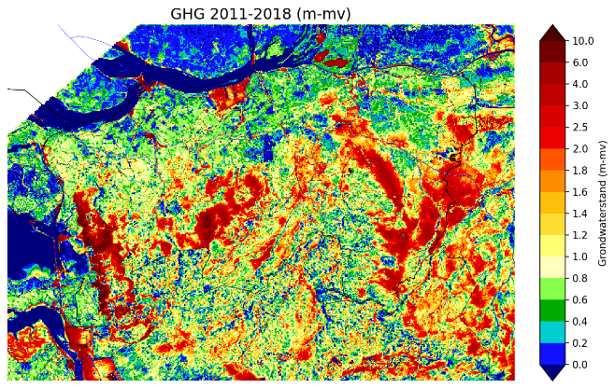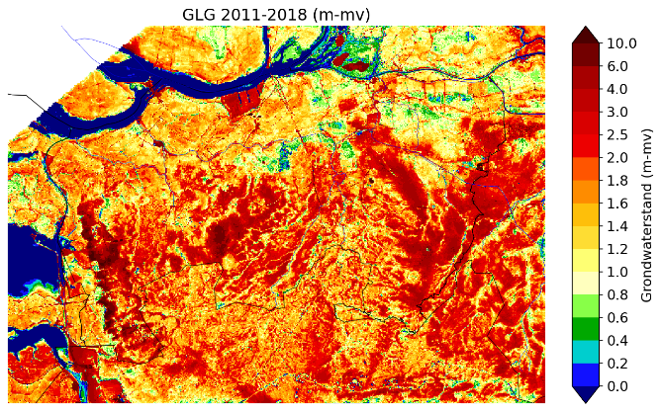

Figuur 4.1 Calculated Average Highest Groundwater Level (GHG) (left) and Average Lowest Groundwater Level (GLG) (right) for the calculation with the online linkage to WOFOST over the period 1-4-2011 to 31-3-2018.

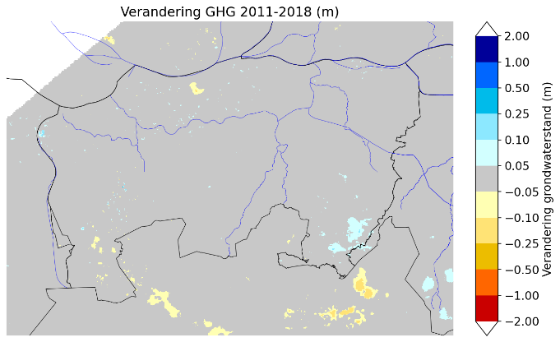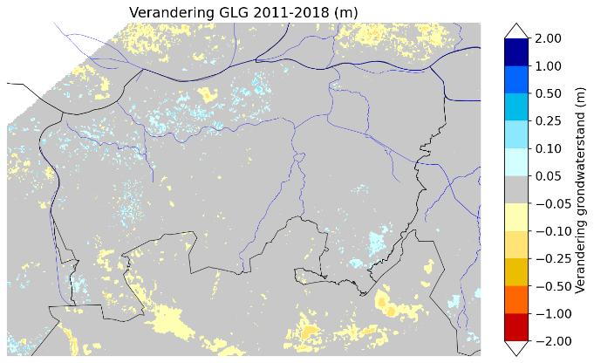

Figuur 4.2 Difference between the calculated GHG (left) and GLG (right) between the calculation without and with the online linkage to WOFOST. The GHG and GLG are calculated over the period from 1-4-2011 to 31-3-2018.

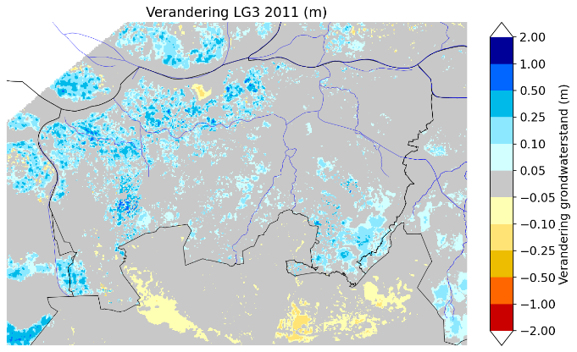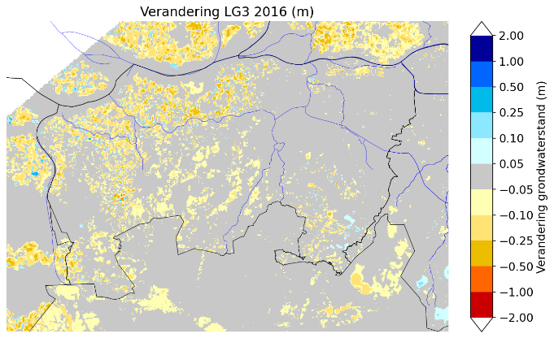

Figuur 4.3 Difference between the calculated LG3 (GLG calculated for 1 year) for the year 2011 (left) and 2016 (right).

### Verdamping

The actual evaporation is calculated in the model by MetaSWAP based on potential evaporation and either static or dynamic crop development (when linked with WOFOST). The average calculated evapotranspiration and actual transpiration are shown in Figures 4.4 and 4.5. The online linkage with WOFOST affects transpiration because, with dynamic crop development, there is feedback between crop growth and hydrology (see Figures 4.6 and 4.7). The average differences are limited, but the differences can be larger on an annual basis (see also Table 4.1).

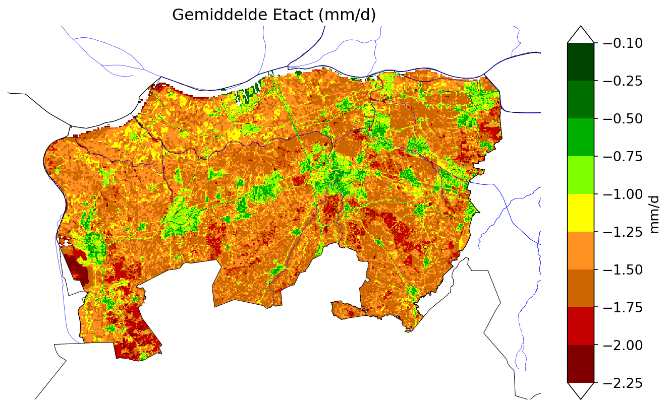

Figuur 4.4 Calculated evapotranspiration (ETact) with the online linkage to WOFOST in mm/day. Averaged over the period 2011-2018.

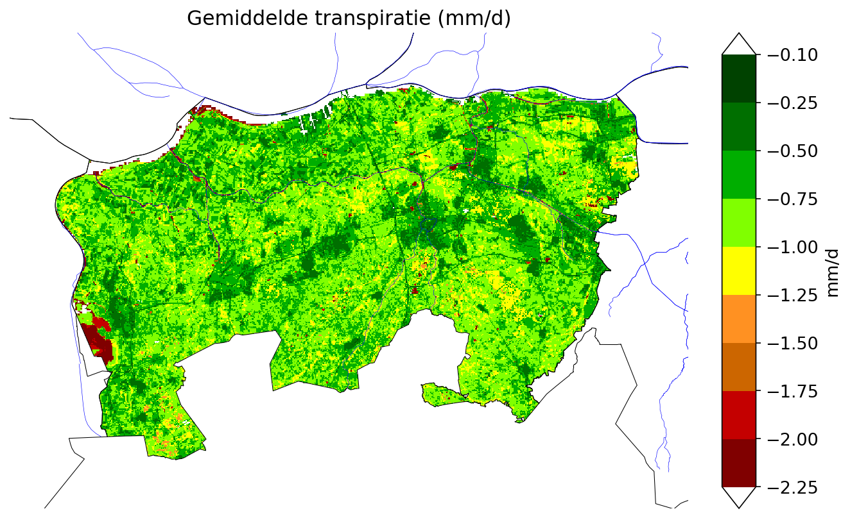

Figuur 4.5 Calculated transpiration (Tact) with the online linkage to WOFOST in mm/day. Averaged over the period 2011-2018.

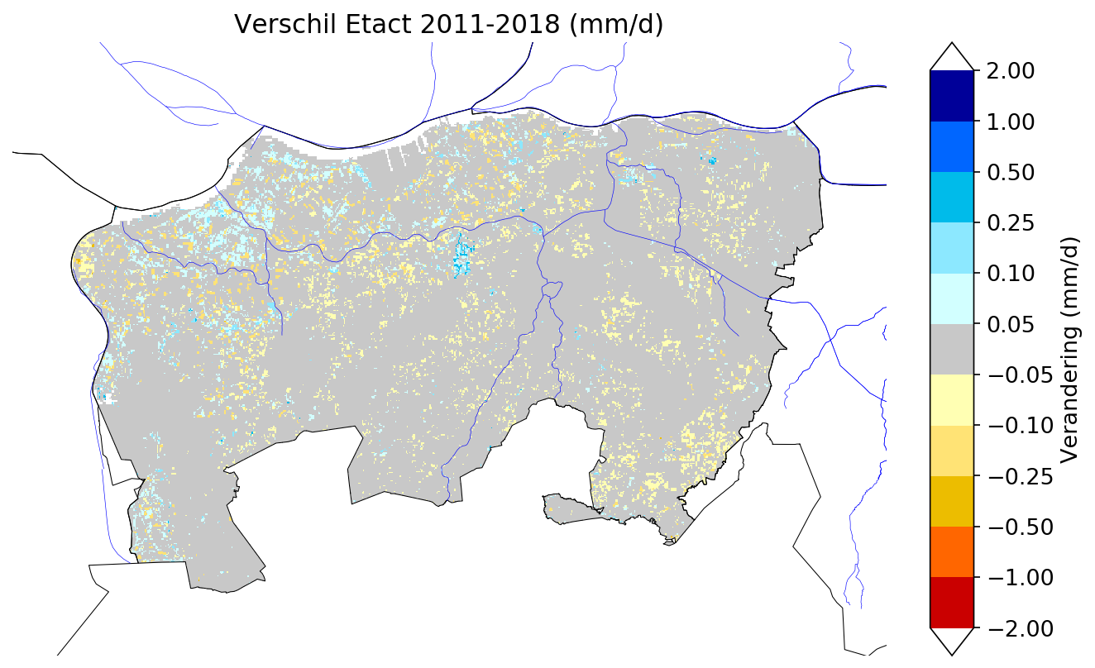

Figuur 4.6 Difference in the calculated evapotranspiration (ETact) with and without the online linkage to WOFOST in mm/day, averaged over the period 2011-2018. Blue indicates less evaporation with the linkage to WOFOST, while orange/red indicates more evaporation with the linkage to WOFOST.

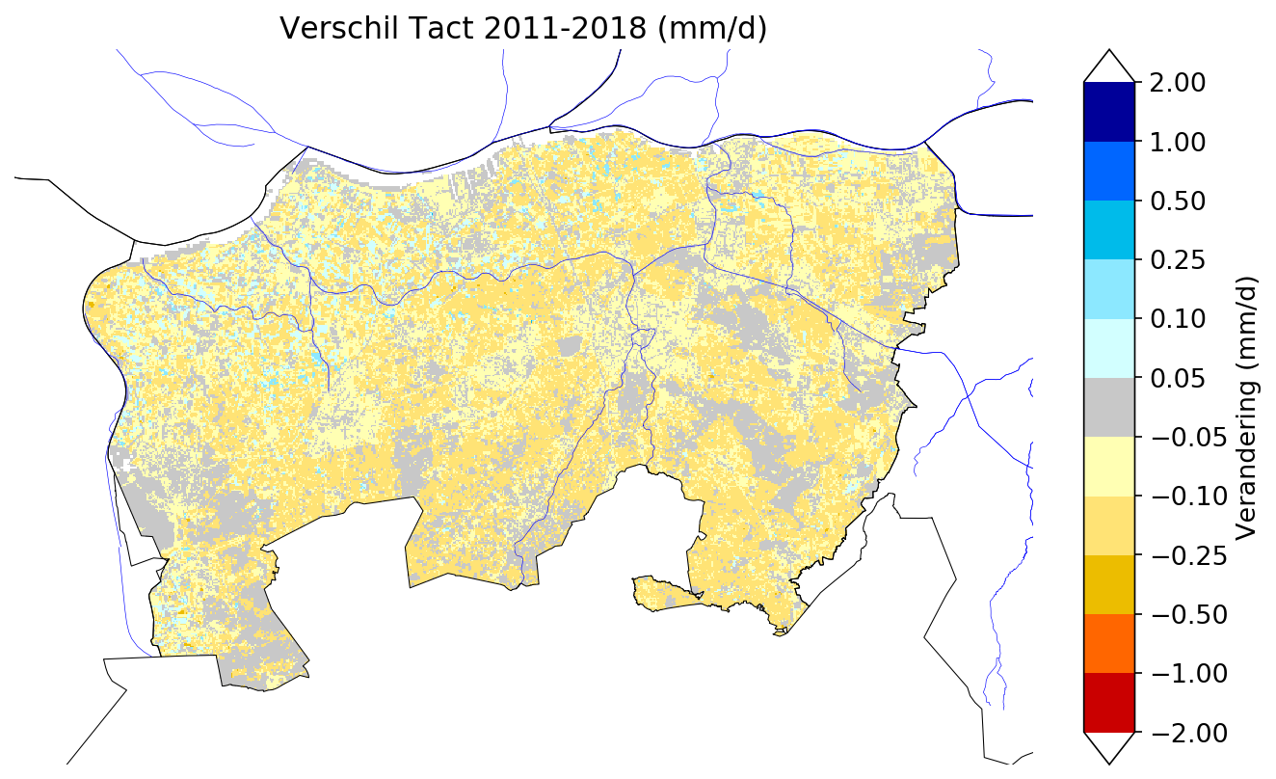

Figuur 4.7 Difference in the calculated transpiration (Tact) with and without the online linkage to WOFOST in mm/day, averaged over the period 2011-2018. Blue indicates less evaporation with the linkage to WOFOST, while orange/red indicates more evaporation with the linkage to WOFOST.

Tabel 4.1 Calculated average transpiration (Tact) and evapotranspiration (ETact) per year in mm/day, and the average change due to static crop development (no online linkage to WOFOST) for the management area of the water board.

|  |  |  |  |  |
| --- | --- | --- | --- | --- |
| Jaar | Tact (mm/d) | Verandering Tact (mm/d) | ETact (mm/dag) | Verandering ETact (mm/d) |
| 2010 | 0.75 | -0.07 | 1.36 | 0.01 |
| 2011 | 0.79 | -0.13 | 1.40 | -0.05 |
| 2012 | 0.79 | -0.08 | 1.47 | 0.00 |
| 2013 | 0.74 | -0.03 | 1.31 | 0.02 |
| 2014 | 0.82 | -0.07 | 1.46 | 0.01 |
| 2015 | 0.78 | -0.09 | 1.42 | -0.01 |
| 2016 | 0.78 | -0.05 | 1.42 | 0.04 |
| 2017 | 0.79 | -0.10 | 1.43 | -0.02 |
| 2018 | 0.78 | -0.05 | 1.33 | 0.02 |

### Groundwater Recharge

Based on the output from MetaSWAP, the average groundwater recharge was determined over the period 2011-2018 (Figure 4.8). Groundwater recharge is shown in mm/day. Cities are clearly identifiable with lower groundwater recharge because part of the precipitation surplus flows away as runoff. The urban area is schematized in MetaSWAP with two svats. In Flanders, some patterns are noticeable, caused by the interpolation of input data for the unsaturated zone model (meteorological input, land use). If dynamic crop development (online linkage with WOFOST) is not considered, the groundwater recharge is slightly higher on average (Figure 4.9).

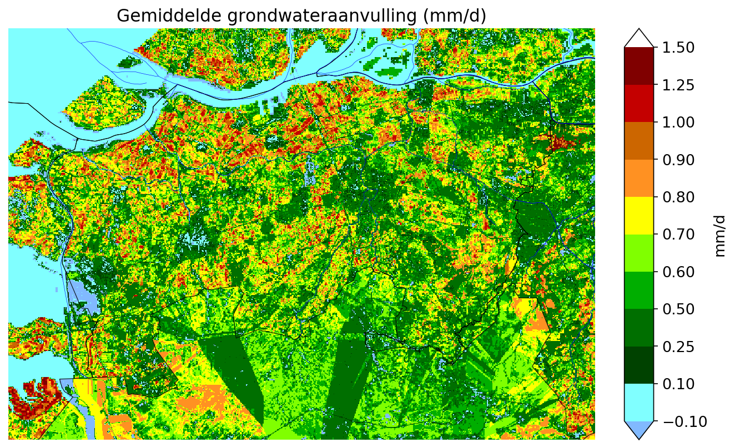

Figuur 4.8 Calculated groundwater recharge with the online linkage to WOFOST in mm/day. Averaged over the period 2011-2018.

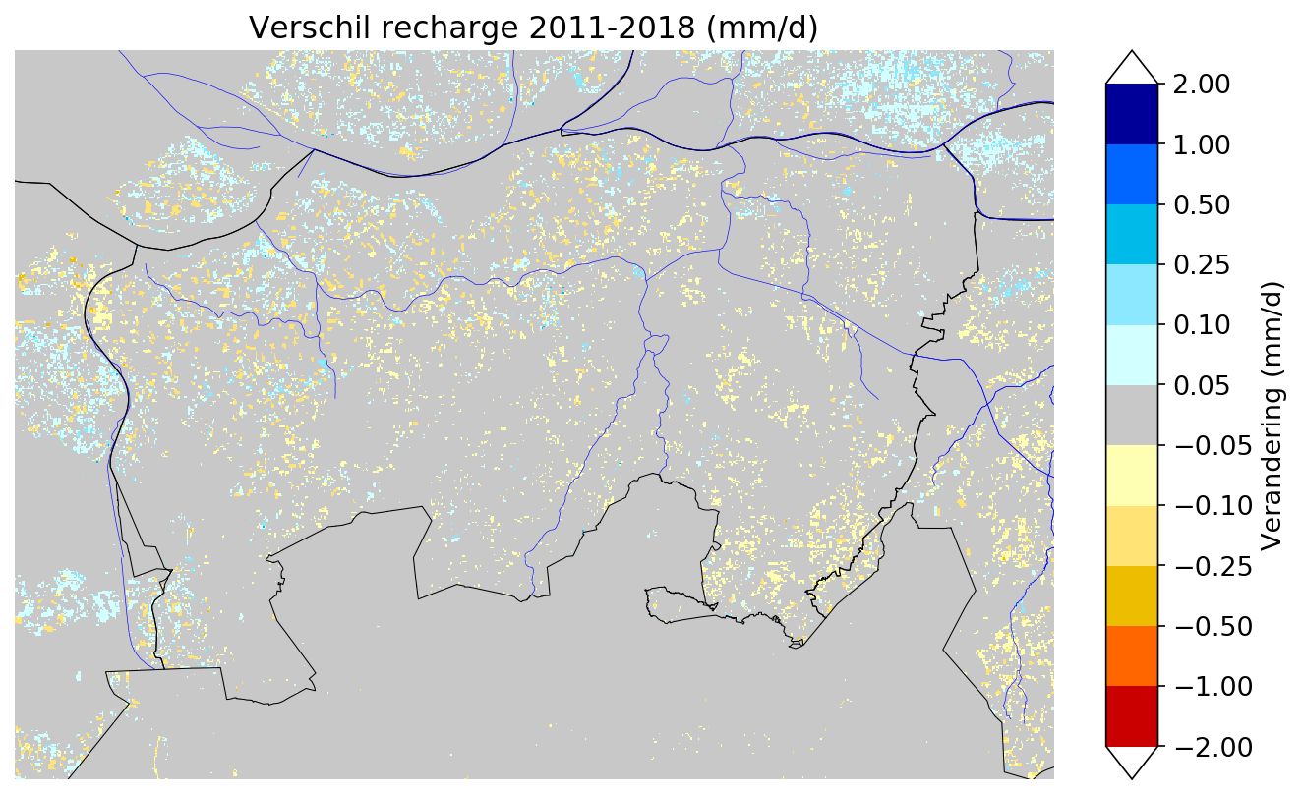

Figuur 4.9 Difference in the calculated groundwater recharge with and without the online linkage to WOFOST in mm/day, averaged over the period 2011-2018. Blue indicates less groundwater recharge without the linkage to WOFOST, while orange/red indicates more groundwater recharge without the linkage to WOFOST.

### Irrigation

The table below shows the calculated amount of irrigation in million m³ per year. In the model, the calculated amount of irrigation is not reduced by factors such as irrigation withdrawals or limited water availability. As a result, the model may overestimate the actual amount of irrigation for dry years.

Tabel 4.2 Berekende beregening in miljoen m3/jaar uit oppervlaktewater en grondwater voor het beheersgebied van het waterschap Brabantse Delta

|  |  |  |  |
| --- | --- | --- | --- |
| jaar | uit oppervlaktewater | uit grondwater | som |
| 2010 | 11.5 | 22.2 | 33.8 |
| 2011 | 6.5 | 12.8 | 19.3 |
| 2012 | 3.7 | 8.7 | 12.4 |
| 2013 | 10.9 | 19.1 | 30.0 |
| 2014 | 5.3 | 10.5 | 15.8 |
| 2015 | 11.2 | 22.5 | 33.6 |
| 2016 | 4.9 | 8.7 | 13.7 |
| 2017 | 10.1 | 19.8 | 29.9 |
| 2018 | 22.3 | 32.6 | 54.9 |

## Validatie

### Grondwaterstanden

The deviations between the calculated and measured GHG (Average Highest Groundwater Level) and GLG (Average Lowest Groundwater Level) are significant for some measurements. For many points, a deviation greater than 0.5m is calculated, and for some measurements, the deviation is greater than 1.0m (see Figures 4.10 to 4.13). The spatial distribution of overestimated and underestimated groundwater levels is generally variable, with both overestimated and underestimated levels occurring close to each other. A few clusters of overestimated groundwater levels can be identified, such as around the Maas near Waalwijk and around Tilburg. In the area south of Rosendaal, groundwater levels are generally underestimated. On the Brabantse Wal, the deviations are large, with nearby measurements showing both overestimated and underestimated levels.

Appendix A shows histograms of the deviations for the average groundwater level, GHG, and GLG. It is clearly visible that a large number of measurements are underestimated.

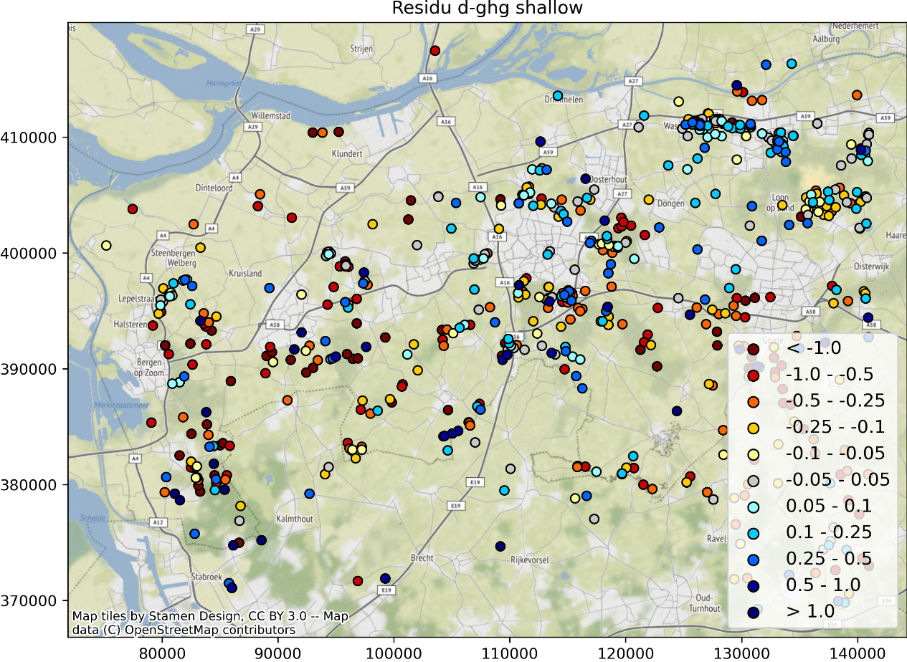

Figuur 4.10 Deviation in the calculated and measured GHG for shallow measurements (calibration set). Red indicates the model calculated groundwater levels too low (too dry), while blue indicates the model calculated levels too high (too wet).

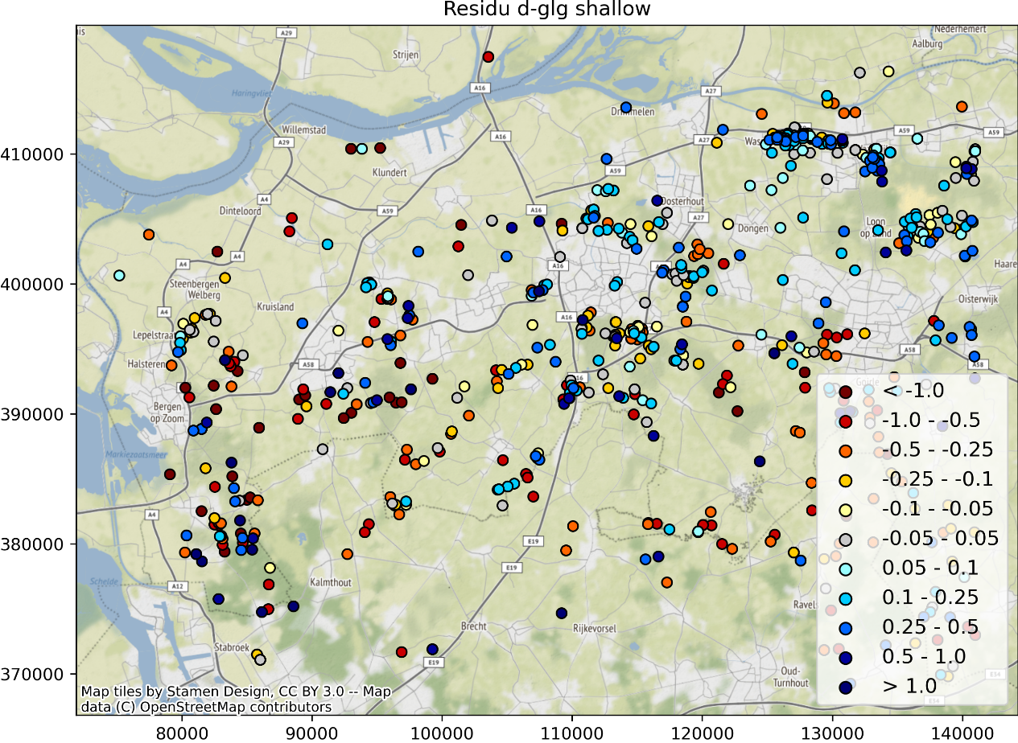

Figuur 4.11 Deviation in the calculated and measured GLG for shallow measurements (calibration set). Red indicates the model calculated groundwater levels too low (too dry), while blue indicates the model calculated levels too high (too wet).

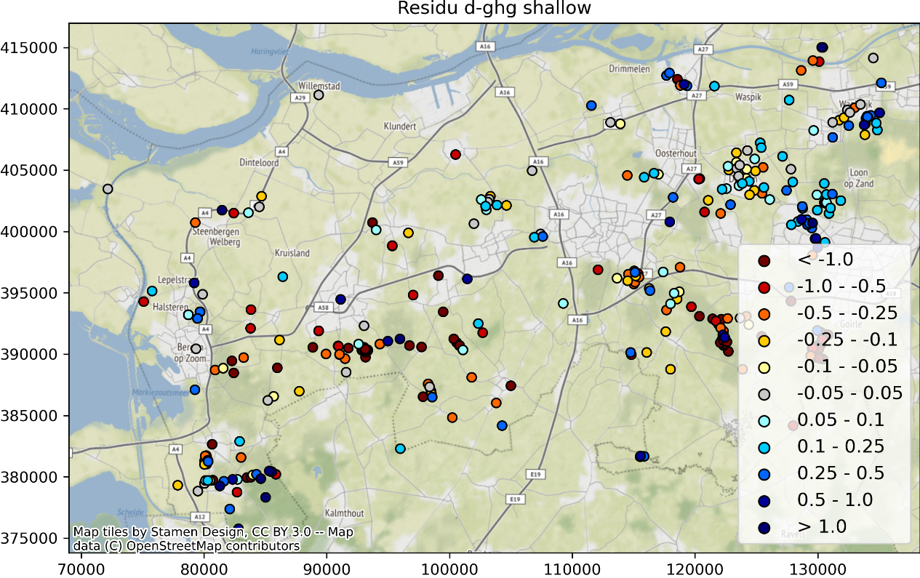

Figuur 4.12 Deviation in the calculated and measured GHG for shallow measurements (water board measurement set). Red indicates the model calculated groundwater levels too low (too dry), while blue indicates the model calculated levels too high (too wet).

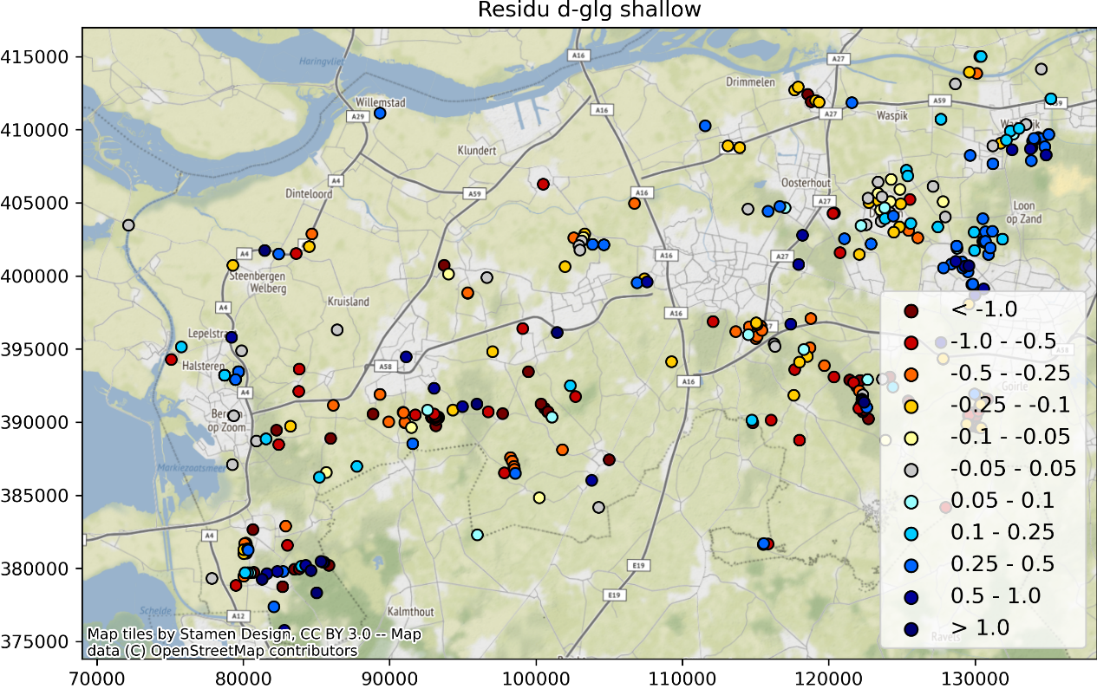

Figuur 4.13 Deviation in the calculated and measured GHG for shallow measurements (water board measurement set). Red indicates the model calculated groundwater levels too low (too dry), while blue indicates the model calculated levels too high (too wet).

After analyzing the differences, it appears that the deviations can have various causes:

* The surface elevation of the measurement does not match the surface elevation value in the model. Large differences in surface elevation, and the derived input from it, lead to discrepancies between the calculated and measured groundwater levels.

For the measurement below, the recorded surface elevation is 1.82 m NAP, while the model has a surface elevation value of 0.58 m NAP.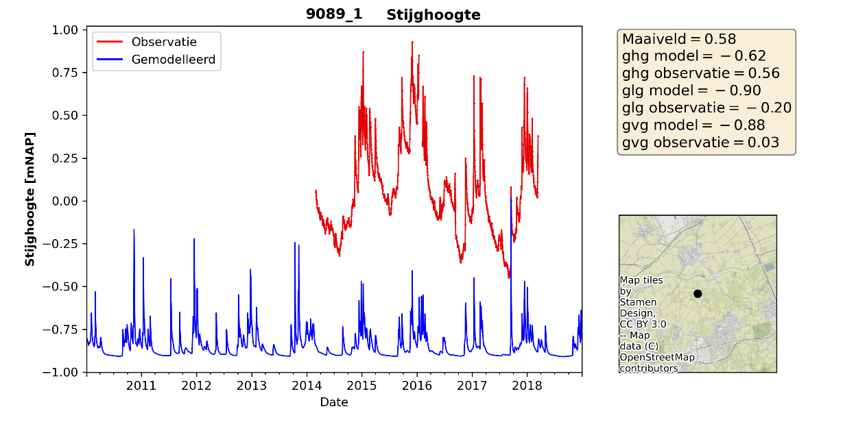

Figuur 4.14 Measured and modeled groundwater level for borehole 9089_1. Surface filter = 1.82 m, top of filter = 0.43 m, bottom of filter = 0.57 m.

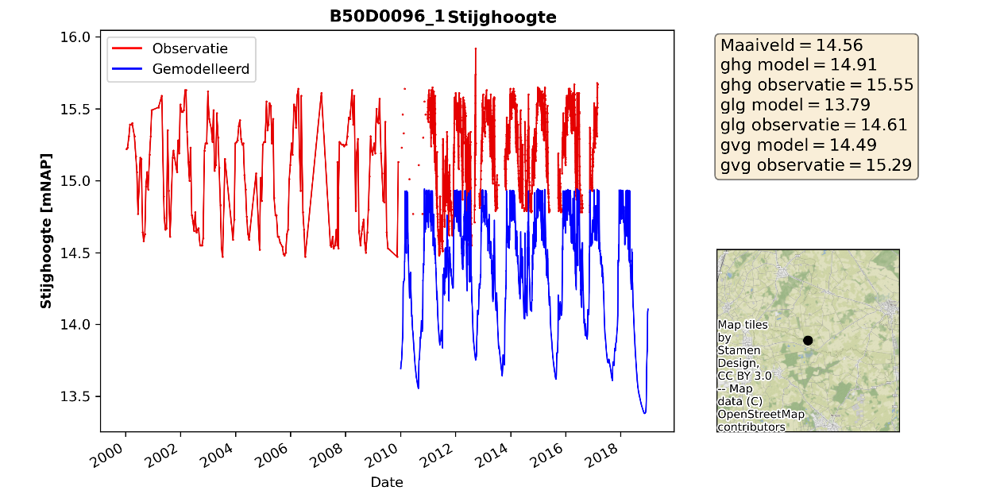

Figuur 4.15 Measured and modeled groundwater level for borehole D50D0096_1. Surface filter = 15.65 m, top of filter = 14.93 m, bottom of filter = 14.43 m.

-Surface water levels or (pipe) drainage levels in the model are either too high or too low. As a result, the high groundwater levels are capped at a different level than in the measurement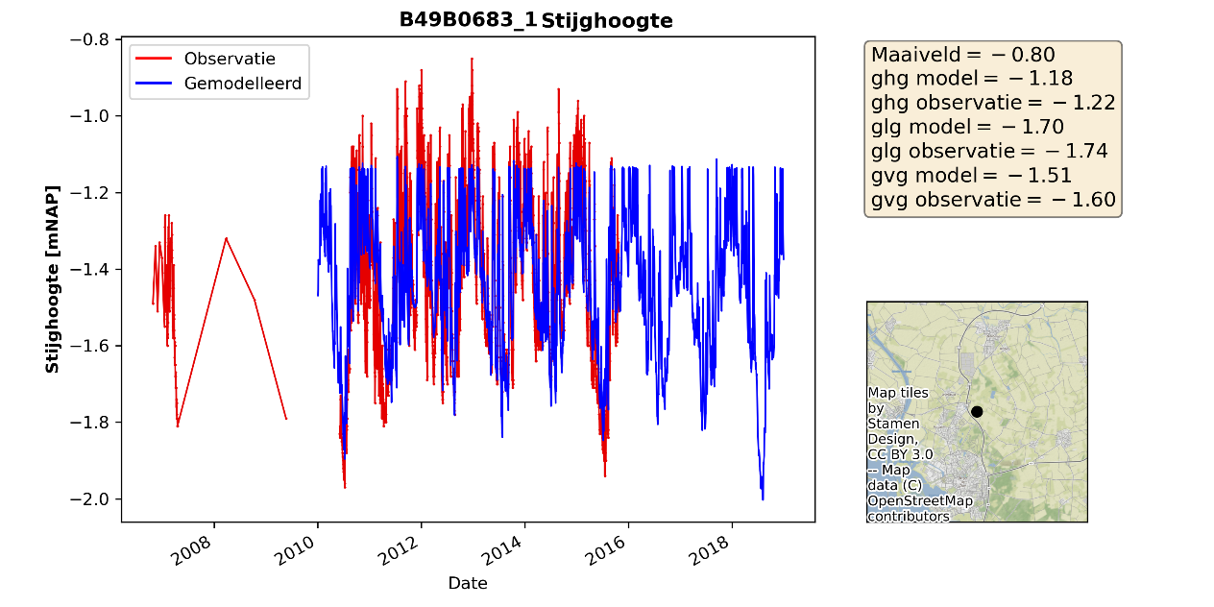

Figuur 4.16 Gemeten en gemodelleerde grondwaterstand buis D49B0683_1.

The calculated dynamics of groundwater levels in summer are lower than in the measurements. This can be caused, depending on the location, by:

* The measurement shows the effect of irrigation withdrawals. In the model, irrigation withdrawal is not extracted per well but rather per irrigated model cell, making the effects of irrigation withdrawals more diffuse.
* In dry conditions, part of the precipitation surplus can quickly reach the groundwater through preferential flow paths, causing groundwater levels to respond rapidly to a rainfall event in summer. This principle is not present in MetaSWAP, where a precipitation surplus is first absorbed by the soil and then flows more slowly to the groundwater.

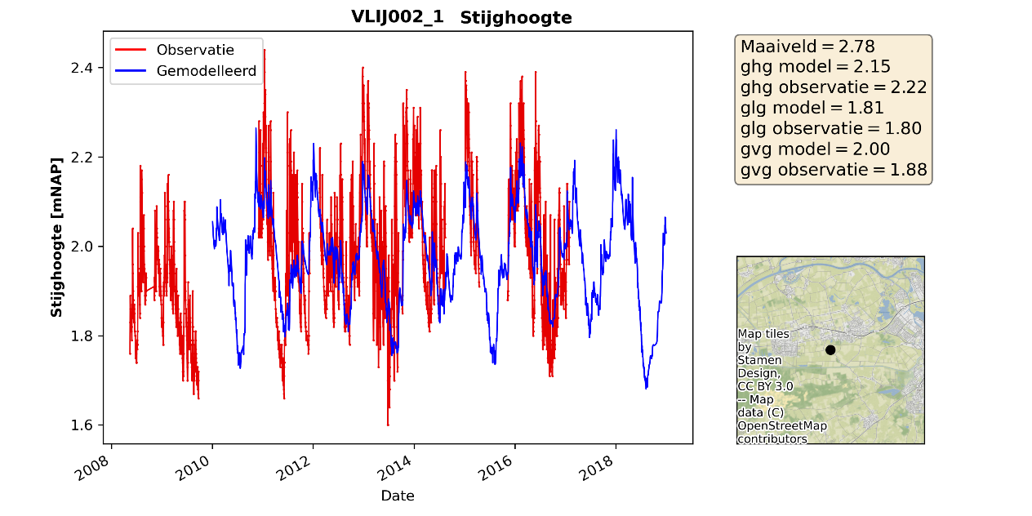

Figuur 4.17 Measured and modeled groundwater level for borehole VLIJ002_1.

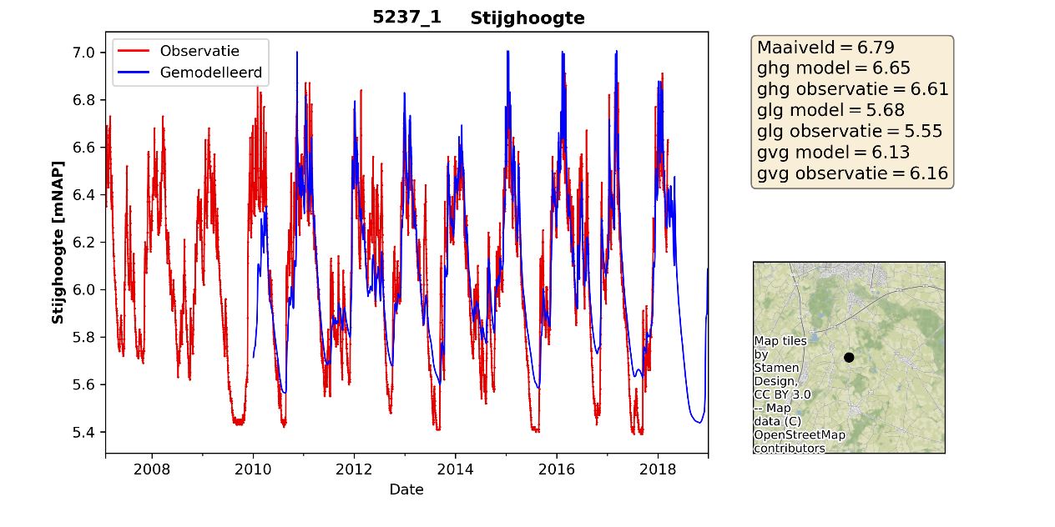

Figuur 4.18 Measured and modeled groundwater level for borehole 5237_1.

* The measurement is not reliable. For example, it may not have been corrected for drying out, there may be trends in the measurement that seem unlikely, or there may be large jumps in the recorded values.

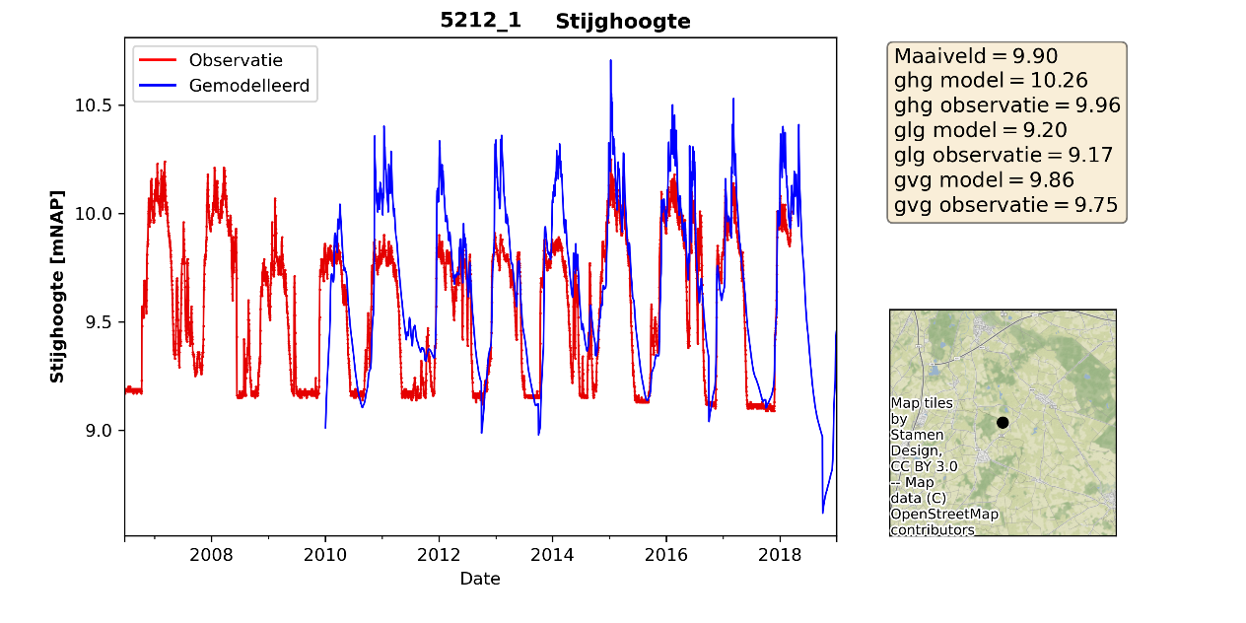

Figuur 4.19 Measured and modeled groundwater level for borehole 5212_1.

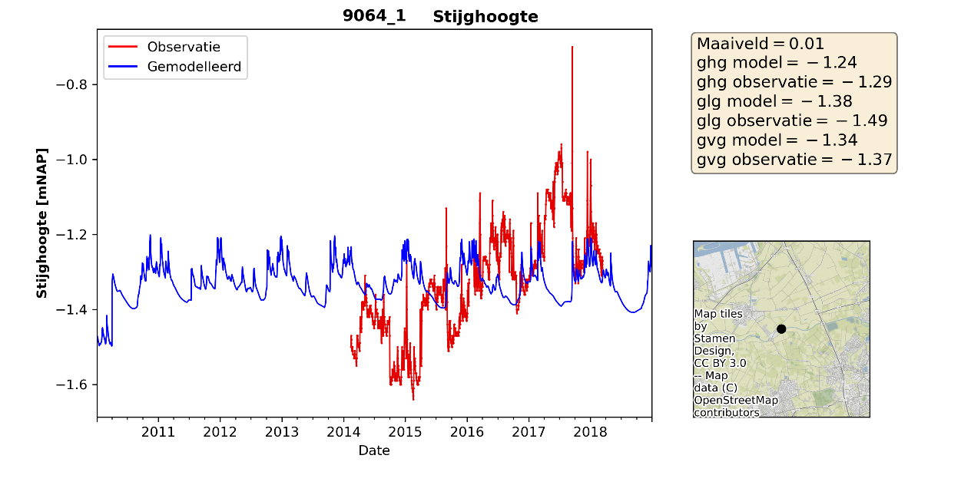

Figuur 4.20 Measured and modeled groundwater level for borehole 5212_1.

### Discharges

For discharge validation, figures were created comparing measured and calculated time series, along with figures showing cumulative discharge for the 5 discharge areas (see Figure 3.1). An example for the Chaamsebeek Ulvenhout area is shown in Figures 4.21 and 4.22. Based on the results for the 5 discharge areas, the following conclusions can be drawn:

* The cumulative discharge calculated with the MF-MetaSWAP model is smaller in all sub-areas compared to the precipitation-discharge modeling according to De Zeeuw-Hellinga. This discrepancy arises from differences in both winter and summer discharge, with winter discharge being larger and thus contributing more significantly to the observed differences.
* The iMOD model calculates higher summer discharge dynamics than the precipitation-discharge model based on De Zeeuw-Hellinga. However, the compared discharge is derived from the De Zeeuw-Hellinga precipitation-discharge model, known for its limitations in accurately modeling low flows. Real measurements (see Appendix G) show more summer discharge dynamics than indicated in Figure 4.21.
* The cumulative discharge for the Turfvaart discharge area is accurate overall. However, in this area, summer discharge is calculated as too low, while autumn/winter discharge is overestimated.

The summer dynamics in the calculated discharge are mainly driven by the surface runoff calculated by MetaSWAP.

Lower cumulative discharge in the iMOD model may be attributed to low groundwater levels. Observations of differences between measured and calculated groundwater levels show that large parts of the area have groundwater levels calculated as too low. These low groundwater levels may be due to underestimated groundwater recharge, low resistance, or an overly low drainage level for drainage features (e.g., pipe drainage and watercourses). Additionally, the iMOD model struggles to reproduce the high peaks calculated by the precipitation-discharge model in winter. This is likely because the discharge occurs on a shorter timescale than the iMOD model's resolution. Precipitation intensity in the iMOD model is processed on a daily basis, whereas actual peak discharges can result from high-intensity precipitation over shorter timescales than a day. It is recommended to further analyze and validate groundwater levels and calculated groundwater recharge during the calibration phase.

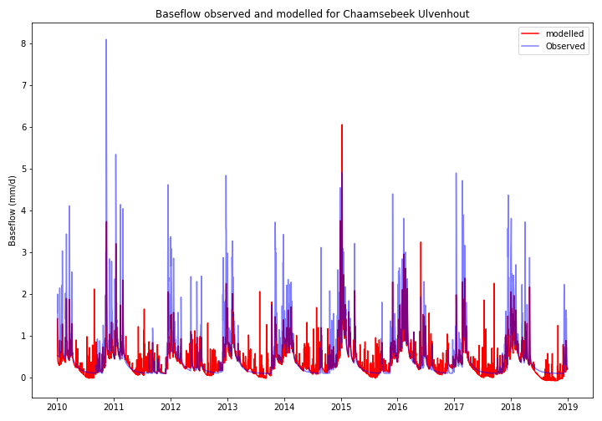

Figuur 4.21 Discharge modeling according to De Zeeuw-Hellinga (observed) and calculated discharge with the iMOD model (modeled) for the Chaamsebeek Ulvenhout discharge area.

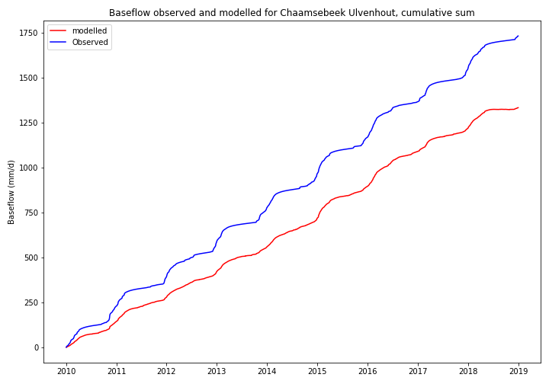

Figuur 4.22 Cumulative discharge modeling according to De Zeeuw-Hellinga (observed) and calculated discharge with the iMOD model (modeled) for the Chaamsebeek Ulvenhout discharge area.

# Recommendations

**Verbeteren meetset grondwaterstanden**

De gebruikte meetsets voor de grondwaterstanden lijken minder goed geschikt als validatie of kalibratie set. In zowel de ijkset (dataset gebruikt in het Brabant Model) als de dataset van het waterschap komen metingen voor waarin sprongen optreden, trends in de metingen aanwezig zijn of het aantal metingen in de tijd sterk varieert (tot soms maar enkele metingen per jaar).

**Verdere analyse naar de oorzaken van de verschillen tussen de berekende en gemeten grondwatertanden.**

De afwijkingen tussen de berekende en de gemeten grondwaterstanden kunnen oplopen tot ruim 1 meter GHG of GLG. In een deel van de gebieden komen positieve verschillen en negatieve verschillen op korte afstand van elkaar voor en zijn er enkele clusters te zien met een vergelijkbare afwijking. Op basis van de bekeken tijdreeksen zijn er verschillende oorzaken mogelijk die de afwijkingen veroorzaken. Aanbevolen wordt om voor de start van een kalibratie een analyse uit te voeren naar de verschillende oorzaken van de afwijkingen zodat dit gebruikt kan worden voor de kalibratiestrategie en het initieel model eventueel nog aangepast kan worden.

**Verdere analyse naar de oorzaken van de verschillen tussen de berekende en gemeten afvoeren.**

De cumulatief berekende afvoer van het model blijft in alle gebieden achter op de meting. Dit zou kunnen beteken dat de grondwateraanvulling in het model te laag wordt berekend. Geadviseerd wordt om een verdere analyse uit te voeren naar de berekende verschillen.

**Actualisatie van het oppervlaktewatersysteem**

Het oppervlaktewatersysteem in het oorspronkelijke Brabant Model verdeeld in verschillende invoerbestanden. Het detailniveau van deze invoerbestanden verschilt sterk. Zo is er voor de legger waterlopen een gedetailleerd bestand beschikbaar op een resolutie van 25m, maar zijn een deel van de waterlopen in de polder geschematiseerd als vlakdekkend oppervlaktewatersysteem op een resolutie van 250m. Geadviseerd wordt om het oppervlaktewatersysteem te actualiseren.

**Regionale kalibratie**

De uitkomsten van het model kan door een regionale kalibratie verbeterd worden. Geadviseerd wordt om voor de kalibratie de meetset en de schematisatie van het oppervlaktewatersysteem te verbeteren.

**Aansluiten bij ontwikkelingen LHM en NHI**

De parametrisatie van MetaSWAP is gebaseerd op de parametrisatie van het LHM 4.1. Momenteel wordt er gewerkt aan een actualisatie van het LHM waarbij ook wordt gekeken naar het recessieverloop van de grondwaterstanden in de zomer en de grondwaterdynamiek bij lage grondwaterstanden.

**Schadeberekeningen WOFOST**

Bij de ontwikkeling van de Waterwijzer Landbouw zijn de schadeberekeningen met WOFOST deels gevalideerd (Mulder, Meijninger et al. 2021). Onder de gebruikers wordt zijn echter nog twijfels over de resultaten van het WOFOST instrument dat bij WWL is gebruikt Bakel and Hoogwoud (2021). Aangezien het WOFOST model wat gebruikt is bij de WWL gelijk is al het WOFOST model wat aan MetaSWAP is gekoppeld, wordt aanbevolen de ontwikkelingen omtrent de validatie van deze resultaten in de gaten te houden.

**Uitbreiden workflows voor modelopzet en postprocessing**

De modelbouw en postprocessing is opgezet in de workflow manager snakemake. Geadviseerd wordt om bij modelaanpassingen of aanvullend postprocessing de bestaande workflows uit te breiden zodat het aanmaken van de modelinvoer reproduceerbaar blijft en de postprocessing snel en consistent ingezet kan worden na het draaien van een modelberekening.

**Rekenserver, hardware requirements**

Het draaien van het model stelt eisen aan de hardware. Door de overstap naar MODFLOW 6, gekoppeld met MetaSWAP en WOFOST is de gewenste opslagcapaciteit en werkgeheugen groter dan bij berekeningen met iMODFLOW (gebaseerd op MODFLOW 2005). De toename in opslagcapaciteit wordt veroorzaakt doordat de ‘output control’ van MODFLOW 6 minder flexibel is te sturen dan binnen iMODFLOW waardoor het niet mogelijk is om maar voor een beperkt aantal lagen en/of tijdstappen uitvoer weg te schrijven. In combinatie met het feit dat de overstap naar MODFLOW 6 een verdubbeling van het aantal modellagen geeft, neemt de gewenste opslagcapaciteit toe. Daarnaast is ook nodig om de uitvoer voordat het bruikbaar is in de iMOD-GUI of imod-python, om te zetten naar een ander formaat (netcdf of *.idf).

Het geheugen gebruik neemt toe door de extra modellagen, de koppeling met MetaSWAP en de koppeling met WOFOST. In Tabel 5.1 is een overzicht gegeven van de het geheugengebruik, rekentijden en de grote van de uitvoer voor de berekeningen die in deze rapportage zijn beschreven. De modellen zijn doorgerekend op de Deltares rekenserver. Hier komt duidelijk naar voren dat de MOFDLOW 6 uitvoer het meeste ruimte in beslag neemt. De conversie naar *.idf is in dit geval uitgevoerd voor alle lagen en de uitvoer van heads en de fluxen van de rivers en drains.

Tabel 5.1 Overzicht van gebruikt geheugen, rekentijd en grote van de opslag voor een berekening met en zonder de online koppeling met WOFOST.

|  |  |  |  |  |  |  |  |
| --- | --- | --- | --- | --- | --- | --- | --- |
| Run | Aantal lagen | Nrow | Rcol | Piek geheugen (GB) | Geheugen tijdens som (GB) | Rekentijd (uur) | Uitvoer (GB) |
| MF6-MS | 37 | 520 | 740 | 20 | 11 | 75 | MF6 native: 400  MF6 idf: 850  MS-WF: 100  Totaal: 1250 |
| MF6-MS-WOFOST | 37 | 520 | 740 | 42 | 19 | 53 | MF6 native: 400  MF6 idf: 850  MS-WF: 150  Totaal: 1300 |

**Postprocessing**

De afgelopen jaren heeft het iMOD instrument zicht ontwikkeld gebaseerd op MODFLOW 2005. De pre en postprocessing tools zijn hierop ook gebaseerd. Het invoerformaat van het MODFLOW 6 model en de uitvoer van MODFLOW 6 kan omgezet worden naar *.idf bestanden zodat de tools die afgelopen jaren zijn ontwikkeld grotendeels bruikbaar blijven. Aanvullend is afgelopen 2 jaar ook ontwikkeld aan een python module die gebruik kan worden in combinatie met de iMOD modellen (imod_python: <https://deltares.gitlab.io/imod/imod-python/>). Deze python module richt zicht meer op de modelleur die ervaring heeft met python en scripting. Verwacht wordt dat een deel van de postprocessing tools voor specifiek MODFLOW 6 in deze omgeving verder ontwikkeld zullen gaan worden. Dit betekent dat ervaring met python bij intensief gebruik van het modelinstrument wenselijk is.

# Referenties

Bakel, J. v. and J. Hoogwoud (2021). "Landsdekkende vergelijking van de droogteschade en natschade volgens de HELP-tabel en de WWL-tabel " Stromingen(2021-2).

Boogaard, H. L., et al. (2011). User’s guide for the WOFOST Control Center 1.8 and WOFOST 7.1.3 crop growth simulation model.

de Wit, A., et al. (2019). "25 years of the WOFOST cropping systems model." Agricultural Systems **168**: 154-167.

The WOFOST cropping systems model has been applied operationally over the last 25 years as part of the MARS crop yield forecasting system. In this paper we provide an updated description of the model and reflect on the lessons learned over the last 25 years. The latter includes issues like system performance, model sensitivity, spatial model setup, parameterization and calibration approaches as well as software implementation and version management. Particularly for spatial model calibrations we provide experience and guidelines on how to execute calibrations and how to evaluate WOFOST model simulation results, particularly under conditions of limited field data availability. As an open source model WOFOST has been a success with at least 10 different implementations of the same concept. An overview is provided for those implementations which are managed by MARS or Wageningen groups. However, the proliferation of WOFOST implementations has also led to questions on the reproducibility of results from different implementations as is demonstrated with an example from MARS. In order to certify that the different WOFOST implementations and versions available can reproduce basic sets of inputs and outputs we make available a large set of test cases as appendix to this publication. Finally, new methodological extensions have been added to WOFOST in simulating the impact of nutrients limitations, extreme events and climate variability. Also, a difference is made in the operational and scientific versions of WOFOST with different licensing models and possible revenue generation. Capitalizing both on academic development as well as model testing in real-world situations will help to enable new applications of the WOFOST model in precision agriculture and smart farming.

Harbaugh, A. W. (2005). MODFLOW-2005 : the U.S. Geological Survey modular ground-water model--the ground-water flow process. Techniques and Methods.

Hughes, J. D., et al. (2017). Documentation for the MODFLOW 6 framework. Techniques and Methods. Reston, VA.

Hunink, J. C., et al. (2020). Toepassing nieuwe koppelsoftware MODFLOW 6 en MetaSWAP op het LHM, Deltares.

Mulder, M., et al. (2021). Validatie Waterwijzer Landbouw, Vergelijking modelresultaten, Groenmonitor, GRAM en HELP. .

Verhagen, F., et al. (2019). Update Hydrologische Gereedschapskist Noord-Brabant.

Vermeulen, P. T. M., et al. (2020). iMOD User Manual. Version 5.2.

Walsum, P. E. V. v. (2020). SIMGRO 8.1.0.1, Input and output reference manual.

WWL (2022). from <https://waterwijzerlandbouw.wur.nl/>.

Bijlages

##### Histogrammen afwijking GHG en GLG

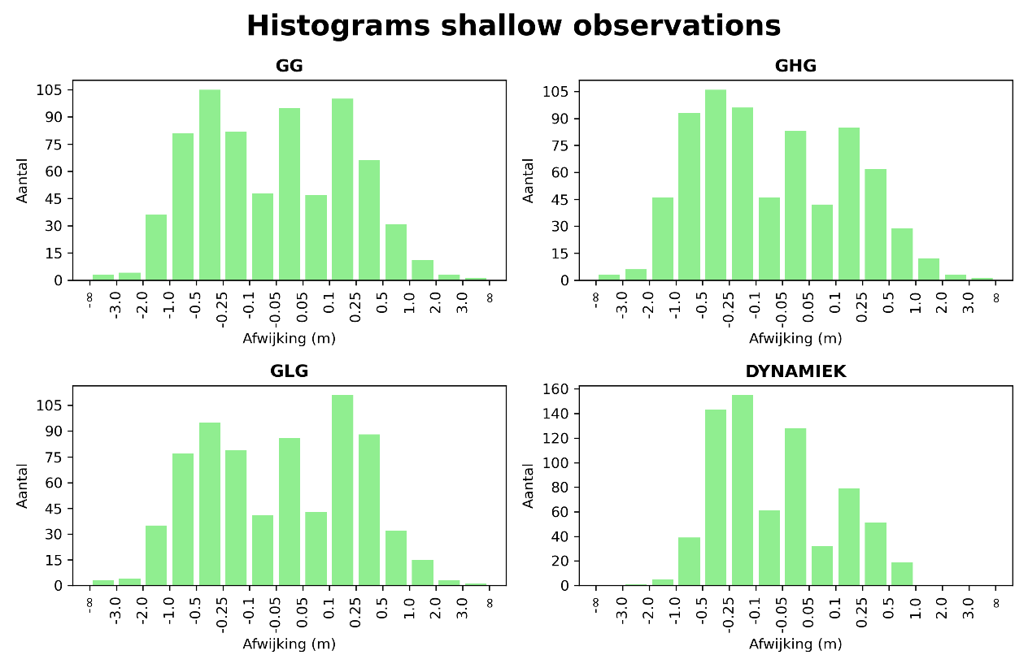

Figuur 6.1 Histogrammen afwijkingen gemiddelde grondwaterstand (GG), GHG, GLG en dynamiek voor de ijkset (Verhagen, Steijn et al. 2019).

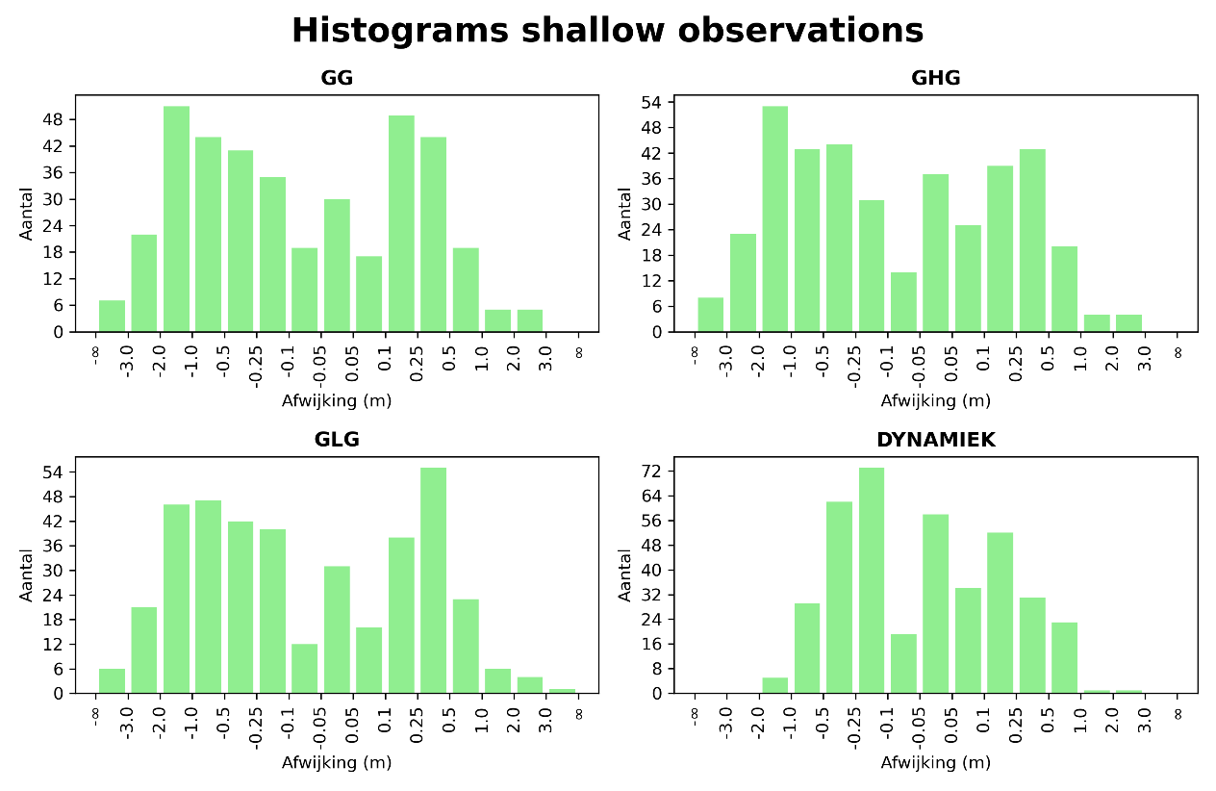

Figuur 6.2 Histogrammen afwijkingen gemiddelde grondwaterstand (GG), GHG, GLG en dynamiek voor de meetset van het waterschap.

##### Aanvullende figuren validatie grondwaterstanden

In deze bijlage zijn voorbeeldfiguren van de berekende en gemeten grondwaterstanden opgenomen bij de mogelijke oorzaken van de berekende verschillen tussen de gemeten en de berekende grondwaterstand. Deze figuren zijn beschikbaar voor alle metingen van de validatieset.

* Het maaiveld van de meting komt niet overeen met de maaiveldwaarde in het model. Door grote verschillen in maaiveld, en de daaruit afgeleide invoer, treden er verschillen op in de berekende en gemeten grondwaterstand.

Het maaiveld van onderstaande meting is volgens de meting 1,82 NAP waarbij het model een maaiveld waarde heeft van 0,58m NAP.



Figuur 6.3 Gemeten en gemodelleerde grondwaterstand buis 9089_1. Maaiveld filter = 1,82m, top filter = 0,43, onderkant filter = 0,57.



Figuur 6.4 Gemeten en gemodelleerde grondwaterstand buis D50D0096_1. Maaiveld filter = 15.65m, top filter = 14.93, onderkant filter = 14.43.

* Peilen van het oppervlaktewater of (buis)drainage zijn in het model te hoog of te laag. Hierdoor worden de hoge grondwaterstanden op een ander niveau afgetopt dan in de meting



Figuur 6.5 Gemeten en gemodelleerde grondwaterstand buis D49B0683_1.

* De berekende dynamiek van de grondwaterstanden in de zomer is lager dan in de metingen. Dit kan, afhankelijk van de locatie, worden veroozaakt door:
  + In de meting is het effect van een beregeningsonttrekking terug te zien. Aangezien in het model de beregeingsonttrekking niet per put wordt onttrokken maar per beregend perceel is het effect van de beregeningsonttrekkingen meer diffuus.
  + In droge situaties kan een deel van het neerslagoverschot door preferentie stroombanen snel bij het grondwater komen waardoor grondwaterstanden snel reageren op een neerslagevent in de zomer. Dit principe is niet aanwezig in MetaSWAP waardoor, een neerslagoverschot eerst in de bodem wordt opgenomen en daarna langzamer naar het grondwater stroomt.



Figuur 6.6 Gemeten en gemodelleerde grondwaterstand buis VLIJ002_1.



Figuur 6.7 Gemeten en gemodelleerde grondwaterstand buis 5237_1.

* De meting is niet betrouwbaar. Zo is er bijvoorbeeld niet over gecorrigeerd voor droogval van de meting, zijn er trends in de meting terug te zien die minder waarschijnlijk zijn of zijn er grote sprongen te zien in de meting.



Figuur 6.8 Gemeten en gemodelleerde grondwaterstand buis 5212_1.



Figuur 6.9 Gemeten en gemodelleerde grondwaterstand buis 5212_1.

##### Figuren validatie afvoeren

In onderstaande figuren zijn voor de verschillende waterbalans gebieden de afvoeren volgens modellering De Zeeuw Hellinga (observed) en berekende afvoer met het iMOD model (modelled) weergegeven.

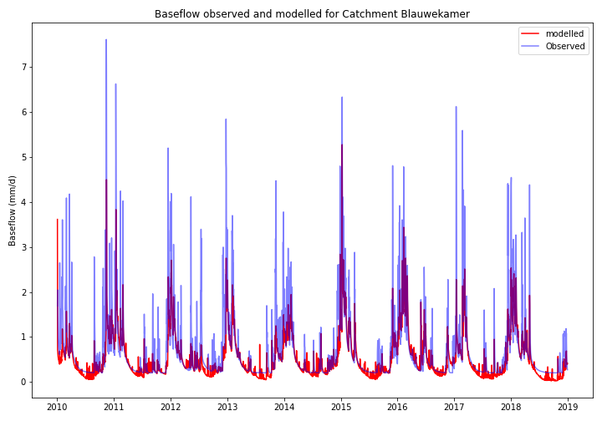

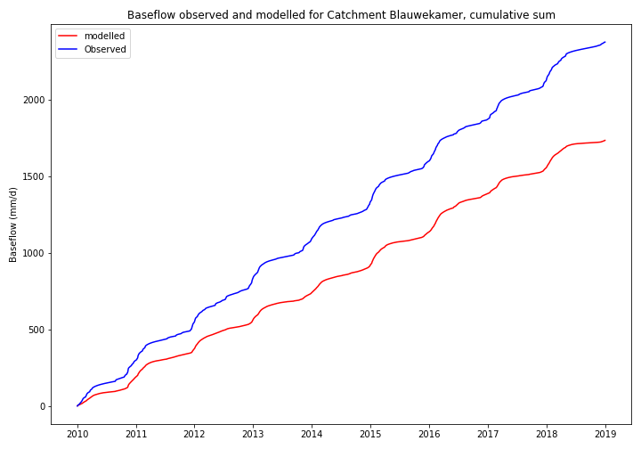

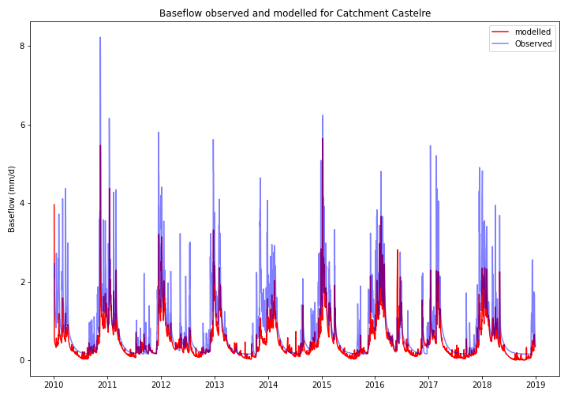

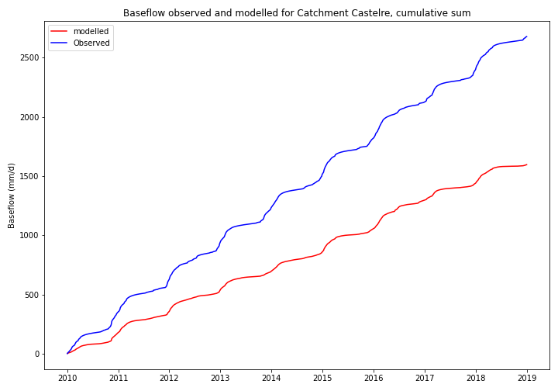

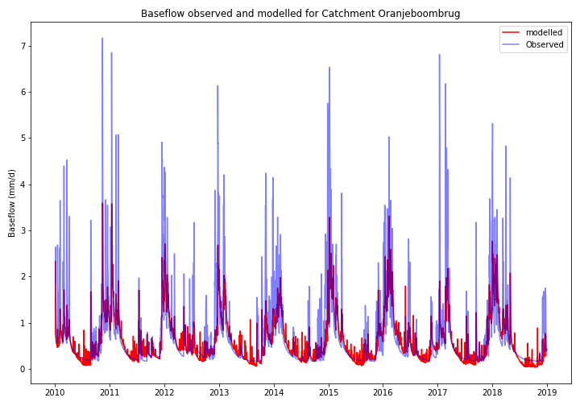

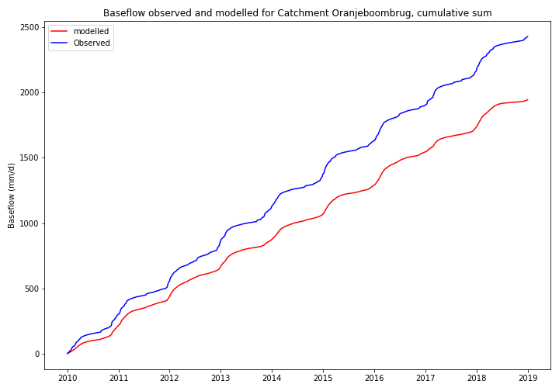

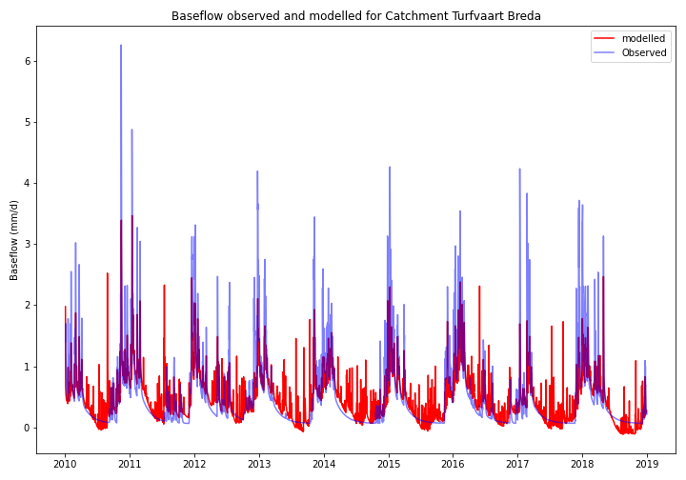

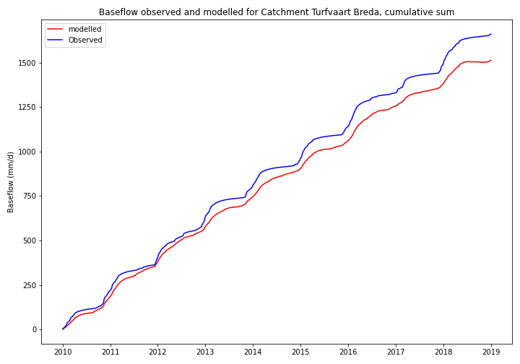





##### Overzicht gebruikte software

|  |  |  |
| --- | --- | --- |
| Software | Beschrijving | Versienummer |
| Modflow6 | Actuele rekencode van MODFLOW (USGS). | 6.2.1 |
| iMOD 5 GUI | Schil voor ontwikkelen, runnen en analyseren van grondwatermodellen (Deltares). | 5.3 |
| iMOD Coupler | MODFLOW API voor koppeling van Modflow6 en MetaSWAP (Deltares). MetaSWAP (v8.1.0.1) is het model voor de onverzadigde zone ontwikkeld door WenR. | 5.3 |
| iMOD Python | Python package voor ontwikkeling, runnen en analyseren van grondwatermodellen (Deltares). | 0.11.3 |
| Python | Internationale programmeertaal waar iMOD Python gebruik van maakt. | 3.10.2 |
| Snakemake | Een op Python gebaseerde workflow manager. | 6.15.5 |

##### Beschrijving starten modelberekening

Memo overdracht modeldata iMOD Brabantse Delta 2021-10-18.pdf

##### Memo “Beknopte beschrijving recente afvoermodelleringen De Zeeuw Hellinga”

Memo geschreven door Kees Vink (Waterschap Brabantse Delta)

Memo

|  |  |
| --- | --- |
| **Van :** | Kees Vink |
| **Aan :** | Kees Peerdeman |
| **Onderwerp :** | Beknopte beschrijving recente afvoermodelleringen De Zeeuw Hellinga |
| **Kopie :** |  |
| **Datum :** | 18 januari 2021 |

Achtergrond

Sinds geruime tijd bestaat de wens om:

* Hiaten in afvoermeetreeksen op te kunnen vullen
* Scenario’s te kunnen berekenen met lumped afvoermodellen.

Redenen van deze wensen:

Op een snelle, gemakkelijke en nauwkeurige manier

* korte termijn afvoerprognoses kunnen maken;
* langere termijn klimaatscenario’s op dagbasis door te kunnen rekenen (met soms een rekenperiode van decennia);
* grondwatermodellen mede te ijken aan de afvoeren.

Dit betreft andere doelstellingen dan de doelen van de SOBEK modellen, die we eerder gebruiken om ruimtelijk gedetailleerde simulaties uit te voeren van het afvoergedrag van beken in vrij-afwaterend gebied. De voorbereiding en het runnen kost daarbij meer tijd dan voor de lumped modellen en er zijn ook meer data voor nodig. Of er SOBEK modellen zijn die nauwkeuriger resultaten van de afvoer opleveren dan de lumped modellen weet ik niet, maar het BOS model is duidelijk niet erg nauwkeurig als het niet met een eenvoudig ARMA model zodanig verschoven wordt dat het matcht met de near real time afvoermetingen.

Enkele maanden geleden hebben Thomas en ik al op basis van correlaties tussen tijdreeksen van verschillende meetstations lineaire regressiemodellen afgeleid. Bij gebruik van 2 a 3 meerdere meetstations kon vrijwel elke afvoerreeks in het vrij-afwaterende gebied opgevuld worden waar gegevens ontbraken. Daar is ook binnen begrepen de extrapolatie van meetreeksen tot en met het heden, dus soms buiten de meetperioden van bepaalde stations die inmiddels zijn opgeheven.

Deze gegevens zijn best al bruikbaar, maar er zijn ook nadelen, vooral doordat alleen de historie kan worden gereconstrueerd voorzover er meetgegevens van goed gecorreleerde stations beschikbaar zijn.

Het voordeel van de lumped afvoermodellen is dat ze niet aangewezen zijn op meetreeksen van afvoeren uit de historie maar in plaats daarvan op neerslag en verdamping en dat ze veel sneller zijn dan de SOBEK modellen (rekentijd en voorbereidingstijd) . Doordat ze veel sneller rekenen dat SOBEK modellen kunnen ze ook veel beter gecalibreerd worden.

Uitwerking

In eerste instantie is gepoogd om WALRUS te gebruiken voor de afvoersimulaties. Na toepassing is besloten dat WALRUS niet voldoet, in eerste instantie om 2 redenen:

1. De rekentijd is te lang, daardoor is goede calibratie van langjarige reeksen niet goed mogelijk
2. Wanneer meerdere korte perioden gekalibreerd worden (dit is qua rekentijd wel haalbaar) dan blijkt dat de modelparameters sterk verschillen per calibratie. Dit is een gevolg van de fysische insteek van het model en de overparametrisatie die daar uit voortvloeit.

In tweede instantie is gerekend met een model op basis van de vergelijking van De Zeeuw Hellinga. Dit model is mathematisch elegant en compact, zodat er een minimum aan parameters per reservoir te calibreren is.

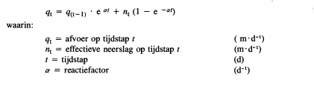

(bron: Cultuurtechnisch Vademecum 1988 , blz 557)

Dit model heeft overwegend tot goede en reproduceerbare resultaten geleid met verklaarde varianties van 62 tot 85% met een gemiddelde van 79% en een gemiddelde absoluut verschil van 0.2 mm/d (zie onderstaande tabel).

|  |  |  |  |
| --- | --- | --- | --- |
| **Datum en tijd berekening** | **Waterloop-Meetstation** | **Verklaarde variantie (%)** | **Gemiddelde absolute afwijking (mm/d)** |
| 2021-01-01 14:12 | Bovenmark_Blauwe_kamer | 82.8 | 0.22 |
| 2021-01-01 14:30 | Bovenmark_galder | 82.16 | 0.11 |
| 2021-01-01 15:03 | Bovenmark_ulvenhoutselaan | 85.19 | 0.2 |
| 2021-01-01 15:24 | Galderschebeek_Galder | 85.03 | 0.21 |
| 2021-01-01 16:04 | Merkske_Castelre | 77.57 | 0.3 |
| 2021-01-01 16:28 | Molenbeek_kleine_aa_P | 61.99 | 0.52 |
| 2021-01-01 16:42 | Molenbeek_nispen | 71.71 | 0.2 |
| 2021-01-01 18:21 | Chaamsebeek_Ulvenhout | 85.2 | 0.16 |
| 2021-01-01 18:28 | Chaamsebeek_Grensweg | 71.66 | 0.07 |
| 2021-01-01 18:45 | BovenMark_Bieberg | 84.18 | 0.2 |
| 2021-01-01 19:06 | Aa of Weerijs_Oranjeboombrug | 83.13 | 0.22 |
| 2021-01-01 19:34 | Turfvaart_Breda | 71.97 | 0.23 |

De verklaarde varianties als fractie zijn vrijwel gelijk aan de waarden van de Nash-Suthcliff model efficiëntie.

De rekentijden van de calibratie zijn in de grootteorde van ca. een half uur, maar als de modellen eenmaal gecalibreerd zijn duurt de berekening slechts enkele seconden.

Vooralsnog is alleen voor de stations die hierboven zijn opgesomd calibraties uitgevoerd. We moeten de code nog wat aanpassen zodat niet alleen gecalibreerd kan worden maar ook prognoses op een gemakkelijke manier berekend kunnen worden met de gecalibreerde modellen.

De modellen bestaan uit 3 parallelle reservoirs, elk met een eigen parameter set bestaande uit:

Reservoir constante Alfa, maximaal bodembergingsdeficiet Mdmax en kwelflux S. In kweflux S is ook gelumped; het vertegenwoordigt niet alleen kwel, maar bijvoorbeeld ook andere min of meer van korte termijn neerslag onafhankelijke fluxen (voorzover van toepassing) zoals de gecalibreerde impact van de droogweerafvoer van een RWZI.

De bijdrage van de verschillende subreservoirs aan het totaal is bepaald tijdens de calibratie.

Enkele voorbeeldfiguren van de resultaten per waterloop-meetstation zijn opgenomen in onderstaande bijlage bij de memo. De prestatie-indicatoren van de calibratie zijn vermeld in de titels van de grafieken:

* NS: Nash-Suthcliff model efficiency
* Avabsdif: gemiddelde absolute verschil gemeten – berekend.
* RMSE: Root mean squared error

Afhankelijk van de formulering van het optimalisatie doel kan het accent van de match meer op hoge afvoeren dan wel juist lage afvoeren worden gelegd.

